

영상처리

보고서 총합

20131000 김찬영

영상처리 오후반

1. 분산

#include <opencv\cv.h>  
#include<opencv\highgui.h>  
#include<opencv\cxcore.h>  
  
#include<stdio.h>  
  
#define **unsigned char** uchar  
  
  
uchar** uc_alloc(**int** size_x, **int** size_y)  
{  
  
 uchar** m;  
 **int** i;  
  
 **if** ((m = (uchar * *)calloc(size_y, **sizeof**(uchar*))) == NULL)  
 {  
 printf("uc_alloc error 1\7\n");  
 exit(0);  
 }  
  
 **for** (i = 0; i < size_y; i++)  
 **if** ((m[i] = (uchar*)calloc(size_x, **sizeof**(uchar))) == NULL) {  
 printf("uc_alloc error 2\7\n");  
 exit(0);  
  
 }  
 **return** m;  
}  
  
**void** read_ucmatrix(**int** size_x, **int** size_y, uchar** ucmatrix, **char**\* filename)  
{  
 **int** i;  
 FILE* f;  
 **if** ((fopen_s(&f, filename, "rb")) != NULL)  
 {  
 printf("%s File open Error! \n", filename);  
 exit(0);  
  
 }  
 **for** (i = 0; i < size_y; i++)  
 **if** (fread(ucmatrix[i], **sizeof**(uchar), size_x, f) != size_x)  
 {  
 printf("Data Read Error! \n");  
 exit(0);  
  
 }  
 fclose(f);  
}  
  
**void** write_ucmatrix(**int** size_x, **int** size_y, uchar** ucmatrix, **char**\* filename)  
{  
 **int** i;  
 FILE* f;  
  
 **if** ((fopen_s(&f, filename, "wb")) != NULL)  
 {  
 printf("%s File open Error! \n", filename);  
 exit(0);  
 }  
  
 **for** (i = 0; i < size_y; i++)  
 **if** (fwrite(ucmatrix[i], **sizeof**(uchar), size_x, f) != size_x)  
 {  
 printf("Data Write Error! \n");  
 exit(0);  
 }  
 fclose(f);  
}  
  
**int** main(**int** argc, **char**\* argv[])  
{  
  
 **int** i, j;  
 IplImage* cvImg;  
 CvSize imgSize;  
 uchar** img;  
  
 **if** (argc != 4)  
 {  
 printf("Exe imgData x_size y_size \n");  
 exit(0);  
 }  
 imgSize.*width* = atoi(argv[2]);  
 imgSize.*height* = atoi(argv[3]);  
 img = uc_alloc(imgSize.*width*, imgSize.*height*);  
 read_ucmatrix(imgSize.*width*, imgSize.*height*, img, argv[1]);  
  
 cvImg = cvCreateImage(imgSize, 8, 1);  
 **for** (i = 0; i < imgSize.*height*; i++)  
 **for** (j = 0; j < imgSize.*width*; j++)  
 {  
  
 ((uchar*)(cvImg->*imageData* + cvImg->*widthStep* * i))[j] = img[i][j];  
  
 }  
 cvNamedWindow(argv[1], 1);  
 cvShowImage(argv[1], cvImg);  
  
 cvWaitKey(0);  
  
 cvDestroyWindow("image");  
 cvReleaseImage(&cvImg);  
  
 getchar();  
 getchar();  
  
 **return** 0;  
  
}

1. 감마
   1. 소스코드

#include <opencv\cv.h>

#include<opencv\highgui.h>

#include<opencv\cxcore.h>

#include <stdio.h>

#define unsigned char uchar

uchar** uc_alloc(int size_x, int size_y) // ��� �޸� �Ҵ� x,y

{

    uchar** m;

    int i;

    if ((m = (uchar * *)calloc(size_y, sizeof(uchar*))) == NULL)

    {

        printf("uc_alloc error 1\7\n");

        exit(0);

    }

    for (i = 0; i < size_y; i++)

        if ((m[i] = (uchar*)calloc(size_x, sizeof(uchar))) == NULL) {

            printf("uc_alloc error 2\7\n");

            exit(0);

        }

    return m;

}

void read_ucmatrix(int size_x, int size_y, uchar** ucmatrix, char* filename)

{

    int i;

    FILE* f;

    if ((fopen_s(&f, filename, "rb")) != NULL)

    {

        printf("%s File open Error! \n", filename);

        exit(0);

    }

    for (i = 0; i < size_y; i++)

        if (fread(ucmatrix[i], sizeof(uchar), size_x, f) != size_x)

        {

            printf("Data Read Error! \n");

            exit(0);

        }

    fclose(f);

}

void write_ucmatrix(int size_x, int size_y, uchar** ucmatrix, char* filename)

{

    int i;

    FILE* f;

    if ((fopen_s(&f, filename, "wb")) != NULL)

    {

        printf("%s File open Error! \n", filename);

        exit(0);

    }

    for (i = 0; i < size_y; i++)

        if (fwrite(ucmatrix[i], sizeof(uchar), size_x, f) != size_x)

        {

            printf("Data Write Error! \n");

            exit(0);

        }

    fclose(f);

}

//평균값

double average(uchar** img, int size_x, int size_y)

{

    double sum = 0, avg;

    int i, j;

    for (i = 0; i < size_x; i++)

    {

        for (j = 0; j < size_y; j++)

        {

            sum += img[i][j];

        }

    }

    avg = sum / ((double)size_x * size_y);

    printf("Average of Image %lf \n", avg);

    return avg;

}

//분산값 구하기

double bunsan(uchar** img, int size_x, int size_y)

{

    double avg = average(img, size_x, size_y);

    double total = 0, valance = 0;

    int i, j;

    for (i = 0; i < size_x; i++)

    {

        for (j = 0; j < size_y; j++)

        {

            valance += (img[i][j] - avg) * (img[i][j] - avg);

        }

    }

    total = valance / (size_x * size_y);

    printf("�л��� %lf \n", total);

    printf("ǥ�������� %lf \n", sqrt(total));

    return avg;

}

void makeBinary(uchar** img, uchar** out, int size_x, int size_y, double avg)

{

    int i, j;

    for (i = 0; i < size_x; i++)

    {

        for (j = 0; j < size_y; j++)

        {

            if (img[i][j] > avg)

                out[i][j] = 255;      // chang value for book with avg-30

            else

                out[i][j] = 0;

        }

    }

}

void PowImg(uchar** img, uchar** Result, int Row, int Col, double gamma)

{

    int i, j;

    double tmp;

    for (i = 0; i < Row; i++)//��

        for (j = 0; j < Col; j++)//��

        {

            tmp = pow(img[j][i] / 255., 1 / gamma);

            if (tmp * 255 > 255)tmp = 1;

            else if (tmp * 255 < 0) tmp = 0;

            tmp = tmp * 255;

            Result[j][i] = tmp;

        }

}

int main(int argc, char* argv[]) {

    int i, j;

    double avg, gamma = 1;

    IplImage* cvImg, * cvImg2;

    CvSize imgSize, imgSize2;

    uchar** img;

    uchar** omg;

    if (argc != 5) {

        printf("Exe imgData x_size y_size \n");

        exit(0);

    }

    imgSize.width = atoi(argv[2]);

    imgSize.height = atoi(argv[3]);

    cvImg = cvCreateImage(imgSize, 8, 1);

    //img ,원본 / omg , 감마값 적용이미지

    img = uc_alloc(imgSize.width, imgSize.height);

    omg = uc_alloc(imgSize.width, imgSize.height);

    //img 이미지 읽기

    read_ucmatrix(imgSize.width, imgSize.height, img, argv[1]);

    //평균값설정

    avg = average(img, imgSize.width, imgSize.height);

    //감마2.45 설정

    PowImg(img, omg, imgSize.width, imgSize.height, 10);

    //평균값 128로 설정

    if (avg < 128) {

        while (avg < 128) {

            gamma = gamma + 0.001;

            PowImg(img, omg, imgSize.width, imgSize.height, gamma);

            avg = average(omg, imgSize.width, imgSize.height);

        }

    }

    else if (avg > 128) {

        while (avg > 128) {

            gamma = gamma - 0.001;

            PowImg(img, omg, imgSize.width, imgSize.height, gamma);

            avg = average(omg, imgSize.width, imgSize.height);

        }

    }

    else

        //구해진 평균값에 따른 감마값을 적용시켜 이미지 추출

        PowImg(img, omg, imgSize.width, imgSize.height, gamma);

    //띄울 사진 설정

    for (i = 0; i < imgSize.width; i++)

        for (j = 0; j < imgSize.height; j++) {

            //img[j][i]일경우 원본사진이 뜨고, omg[j][i]일경우 감마작업을 한 사진이 뜬다.

            ((uchar*)(cvImg->imageData + cvImg->widthStep * j))[i] = img[j][i];

        }

    //감마작업한 사진을 저장한다.

    write_ucmatrix(imgSize.width, imgSize.height, omg, argv[4]);

    //윈도우창 이름설정

    cvNamedWindow(argv[1], 0);

    //보여줄 이미지 설정

    cvShowImage(argv[1], cvImg);

    cvWaitKey(0);

    cvReleaseImage(&cvImg);

    return 0;

}

* 1. 실행결과
     1. 원본사진 cman.256

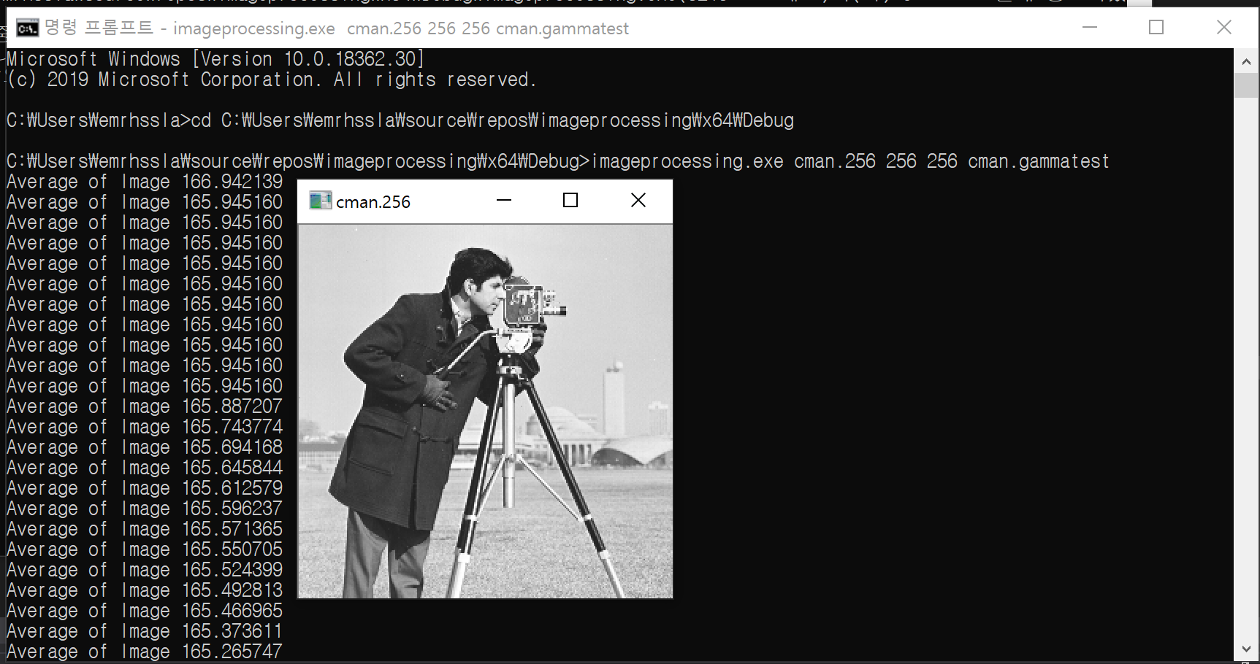

* + 1. 감마작업사진 cman.256

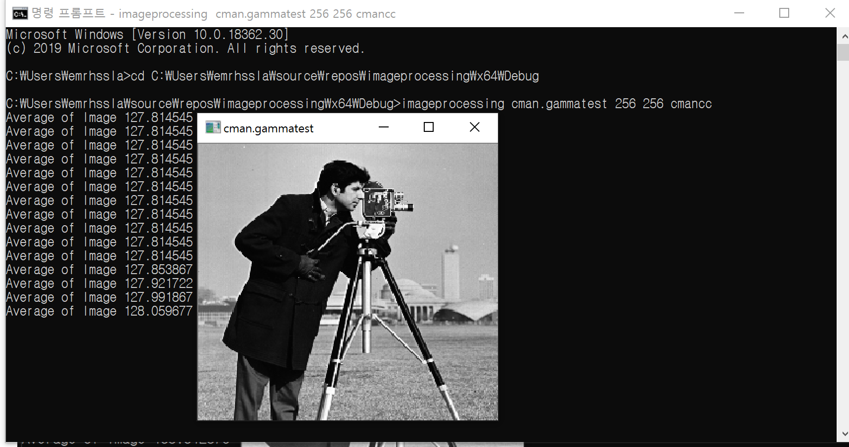

1. bit slicing

#include <opencv\cv.h>  
#include<opencv\highgui.h>  
#include<opencv\cxcore.h>  
  
#include <stdio.h>  
  
#define **unsigned char** uchar  
  
  
uchar** uc_alloc(**int** size_x, **int** size_y) // ��� �޸� �Ҵ� x,y  
{  
  
 uchar** m;  
 **int** i;  
  
 **if** ((m = (uchar * *)calloc(size_y, **sizeof**(uchar*))) == NULL)  
 {  
 printf("uc_alloc error 1\7\n");  
 exit(0);  
 }  
  
 **for** (i = 0; i < size_y; i++)  
 **if** ((m[i] = (uchar*)calloc(size_x, **sizeof**(uchar))) == NULL) {  
 printf("uc_alloc error 2\7\n");  
 exit(0);  
  
 }  
 **return** m;  
}  
  
**void** read_ucmatrix(**int** size_x, **int** size_y, uchar** ucmatrix, **char**\* filename)  
{  
 **int** i;  
 FILE* f;  
 **if** ((fopen_s(&f, filename, "rb")) != NULL)  
 {  
 printf("%s File open Error! \n", filename);  
 exit(0);  
  
 }  
 **for** (i = 0; i < size_y; i++)  
 **if** (fread(ucmatrix[i], **sizeof**(uchar), size_x, f) != size_x)  
 {  
 printf("Data Read Error! \n");  
 exit(0);  
  
 }  
 fclose(f);  
}  
  
**void** write_ucmatrix(**int** size_x, **int** size_y, uchar** ucmatrix, **char**\* filename)  
{  
 **int** i;  
 FILE* f;  
  
 **if** ((fopen_s(&f, filename, "wb")) != NULL)  
 {  
 printf("%s File open Error! \n", filename);  
 exit(0);  
 }  
  
 **for** (i = 0; i < size_y; i++)  
 **if** (fwrite(ucmatrix[i], **sizeof**(uchar), size_x, f) != size_x)  
 {  
 printf("Data Write Error! \n");  
 exit(0);  
 }  
 fclose(f);  
}  
//평균값  
**double** average(uchar** img, **int** size_x, **int** size_y)  
{  
 **double** sum = 0, avg;  
 **int** i, j;  
  
 **for** (i = 0; i < size_x; i++)  
 {  
 **for** (j = 0; j < size_y; j++)  
 {  
 sum += img[i][j];  
 }  
 }  
 avg = sum / ((**double**)size_x * size_y);  
 printf("Average of Image %lf \n", avg);  
  
 **return** avg;  
}  
//분산값 구하기  
**double** bunsan(uchar** img, **int** size_x, **int** size_y)  
{  
 **double** avg = average(img, size_x, size_y);  
 **double** total = 0, valance = 0;  
 **int** i, j;  
 **for** (i = 0; i < size_x; i++)  
 {  
 **for** (j = 0; j < size_y; j++)  
 {  
 valance += (img[i][j] - avg) * (img[i][j] - avg);  
 }  
 }  
 total = valance / (size_x * size_y);  
 printf("�л��� %lf \n", total);  
 printf("ǥ�������� %lf \n", sqrt(total));  
  
 **return** avg;  
  
}  
  
**void** makeBinary(uchar** img, uchar** out, **int** size_x, **int** size_y, **double** avg)  
{  
 **int** i, j;  
  
 **for** (i = 0; i < size_x; i++)  
 {  
 **for** (j = 0; j < size_y; j++)  
 {  
 **if** (img[i][j] > avg)  
 out[i][j] = 255; // chang value for book with avg-30  
 **else** out[i][j] = 0;  
 }  
 }  
}  
  
**void** PowImg(uchar** img, uchar** Result, **int** Row, **int** Col, **double** gamma)  
{  
 **int** i, j;  
 **double** tmp;  
  
 **for** (i = 0; i < Row; i++)//��  
 **for** (j = 0; j < Col; j++)//��  
 {  
 tmp = pow(img[j][i] / 255., 1 / gamma);  
  
 **if** (tmp * 255 > 255)tmp = 1;  
 **else if** (tmp * 255 < 0) tmp = 0;  
  
 tmp = tmp * 255;  
  
 Result[j][i] = tmp;  
 }  
}  
  
**void** BitSlicing(uchar** img, uchar** Result, **int** Row, **int** Col, **int** position)  
{  
 **int** i, j;  
 uchar mask = 0x01;  
 mask <<= position;  
  
 **for** (i = 0; i < Row; i++)  
 **for** (j = 0; j < Col; j++)  
 {  
 **if** ((mask & img[j][i]) == pow(2, position))  
 {  
 Result[j][i] = pow(2, position);  
 }  
 **else** {  
 Result[j][i] = 0;  
 }  
  
 }  
}  
**void** BitImage(uchar** img, uchar** Result, **int** Row, **int** Col, **int** sum)  
{  
 **int** i, j, k;  
 uchar mask = 0x80;  
  
 **for** (k = 1; k < sum; k++)  
 {  
 mask = mask + (0x80 >> k);  
 }  
  
 **for** (i = 0; i < Row; i++)  
 **for** (j = 0; j < Col; j++)  
 {  
 Result[i][j] = img[i][j] & mask;  
 }  
}  
**double** myaver(uchar** img, **int** Row, **int** Col) {  
 **int** i, j, k;  
 **double** pp[256] = { 0 };  
 **double** ssum = 0;  
  
 **for** (k = 0; k < 256; k++) {  
 **for** (i = 0; i < Row; i++) {  
 **for** (j = 0; j < Col; j++) {  
 **if** (img[i][j] == k) {  
 pp[k] += 1;  
 }  
 }  
 }  
 ssum += ((pp[k] * k) / (Row * Col));  
  
 }  
 **return** ssum;  
  
}  
  
  
**int** main(**int** argc, **char**\* argv[])  
{  
  
 **double** avg = 0;  
 **double** gamma = 0.5;  
 IplImage* cvImg;  
 CvSize imgSize;  
 uchar** img;  
 uchar** rimg;  
  
 **if** (argc != 5)  
 {  
 printf("Exe imgData x_size y_size resultimg \n");  
 exit(0);  
 }  
 imgSize.*width* = atoi(argv[2]);  
 imgSize.*height* = atoi(argv[3]);  
 img = uc_alloc(imgSize.*width*, imgSize.*height*);  
 rimg = uc_alloc(imgSize.*width*, imgSize.*height*); //결과 이미지를 저장할 곳을 할당해줌  
 read_ucmatrix(imgSize.*width*, imgSize.*height*, img, argv[1]);  
 BitImage(img, rimg, imgSize.*width*, imgSize.*height*, 3);  
 //addImage(img, rimg, imgSize.width, imgSize.height, 3);  
 write_ucmatrix(imgSize.*width*, imgSize.*height*, rimg, argv[4]); //결과값 저장  
 average(rimg, imgSize.*width*, imgSize.*height*);  
  
 /*cvImg = cvCreateImage(imgSize, 8, 1);  
 for (i = 0; i < imgSize.height; i++)  
 for (j = 0; j < imgSize.width; j++)  
 {  
 ((uchar*)(cvImg->imageData + cvImg->widthStep * i))[j] = img[i][j];  
 }  
 cvNamedWindow(argv[1], 1);  
 cvShowImage(argv[1], cvImg);  
 cvWaitKey(0);  
 cvDestroyWindow("image");  
 cvReleaseImage(&cvImg);  
 getchar();  
 getchar();*/  
  
 **return** 0;  
  
}

1. add noise image

#include <opencv\cv.h>  
#include<opencv\highgui.h>  
#include<opencv\cxcore.h>  
  
#include <stdio.h>  
#include <time.h>  
  
#define **unsigned char** uchar  
  
  
uchar** uc_alloc(**int** size_x, **int** size_y)  
{  
  
 uchar** m;  
 **int** i;  
  
 **if** ((m = (uchar * *)calloc(size_y, **sizeof**(uchar*))) == NULL)  
 {  
 printf("uc_alloc error 1\7\n");  
 exit(0);  
 }  
  
 **for** (i = 0; i < size_y; i++)  
 **if** ((m[i] = (uchar*)calloc(size_x, **sizeof**(uchar))) == NULL) {  
 printf("uc_alloc error 2\7\n");  
 exit(0);  
  
 }  
 **return** m;  
}  
  
**int**\*\* i_alloc(**int** size_x, **int** size_y)  
{  
  
 **int**\*\* m;  
 **int** i;  
  
 **if** ((m = (**int**\*\*)calloc(size_y, **sizeof**(**int**\*))) == NULL)  
 {  
 printf("i_alloc error 1\7\n");  
 exit(0);  
 }  
  
 **for** (i = 0; i < size_y; i++)  
 **if** ((m[i] = (**int**\*)calloc(size_x, **sizeof**(**int**))) == NULL) {  
 printf("i_alloc error 2\7\n");  
 exit(0);  
  
 }  
 **return** m;  
}  
  
  
  
**void** read_ucmatrix(**int** size_x, **int** size_y, uchar** ucmatrix, **char**\* filename)  
{  
 **int** i;  
 FILE* f;  
 **if** ((fopen_s(&f, filename, "rb")) != NULL)  
 {  
 printf("%s File open Error! \n", filename);  
 exit(0);  
  
 }  
 **for** (i = 0; i < size_y; i++)  
 **if** (fread(ucmatrix[i], **sizeof**(uchar), size_x, f) != size_x)  
 {  
 printf("Data Read Error! \n");  
 exit(0);  
  
 }  
 fclose(f);  
}  
  
**void** write_ucmatrix(**int** size_x, **int** size_y, uchar** ucmatrix, **char**\* filename)  
{  
 **int** i;  
 FILE* f;  
  
 **if** ((fopen_s(&f, filename, "wb")) != NULL)  
 {  
 printf("%s File open Error! \n", filename);  
 exit(0);  
 }  
  
 **for** (i = 0; i < size_y; i++)  
 **if** (fwrite(ucmatrix[i], **sizeof**(uchar), size_x, f) != size_x)  
 {  
 printf("Data Write Error! \n");  
 exit(0);  
 }  
 fclose(f);  
}  
  
**double** uniform()  
{  
  
 **return** ((**double**)(rand() & RAND_MAX) / RAND_MAX - 0.5);  
}  
  
**double** gaussian()  
{  
 **static int** ready = 0;  
 **static double** gstore;  
 **double** v1, v2, r, fac, gaus;  
 **double** uniform();  
  
 **if** (ready == 0) {  
 **do** {  
 v1 = 2. * uniform();  
 v2 = 2. * uniform();  
 r = v1 * v1 + v2 * v2;  
 } **while** (r > 1.0);  
  
 fac = sqrt(-2. * log(r) / r);  
 gstore = v1 * fac;  
 gaus = v2 * fac;  
 ready = 1;  
 }  
 **else** {  
 ready = 0;  
 gaus = gstore;  
 }  
 **return**(gaus);  
}  
// many번까지 noise추가  
**void** noiseGaus(uchar** img, uchar** Result, **int** Row, **int** Col, **int** many)  
{  
 **int** i, j, k;  
 **double** gaus;  
 **int**\*\* tmp;  
 tmp = i_alloc(Row, Col);  
 **for** (k = 0; k < many; k++)  
 {  
 **for** (i = 0; i < Row; i++)  
 **for** (j = 0; j < Col; j++)  
 {  
 gaus = gaussian();  
 tmp[i][j] += img[i][j] + (gaus * 30);  
 }  
 }  
 **for** (**int** j = 0; j < Row; j++)  
 **for** (**int** t = 0; t < Col; t++)  
 {  
 Result[j][t] = (tmp[j][t] / many);  
 }  
}  
  
  
**int** main(**int** argc, **char**\* argv[])  
{  
  
 **int** i, j, count;  
 IplImage* cvImg;  
 CvSize imgSize;  
 uchar** img, ** result_img, ** result_img2;  
 **int**\*\* tmp;  
  
 srand(time(NULL));  
  
 **if** (argc != 5)  
 {  
 printf("Exe imgData x_size y_size \n");  
 exit(0);  
 }  
  
 imgSize.*width* = atoi(argv[2]);  
 imgSize.*height* = atoi(argv[3]);  
 count = atoi(argv[4]);  
  
 img = uc_alloc(imgSize.*width*, imgSize.*height*);  
 result_img = uc_alloc(imgSize.*width*, imgSize.*height*);  
  
 read_ucmatrix(imgSize.*width*, imgSize.*height*, img, argv[1]);  
  
 //gausAdd(img, result_img, imgSize.width, imgSize.height);  
 noiseGaus(img, result_img, imgSize.*width*, imgSize.*height*, count);  
  
 cvImg = cvCreateImage(imgSize, 8, 1);  
  
  
 **for** (i = 0; i < imgSize.*height*; i++)  
 **for** (j = 0; j < imgSize.*width*; j++)  
 {  
  
 ((uchar*)(cvImg->*imageData* + cvImg->*widthStep* * i))[j] = (result_img[i][j]);  
  
 }  
  
  
 cvNamedWindow(argv[1], 1);  
 cvShowImage(argv[1], cvImg);  
  
 cvWaitKey(0);  
  
 cvDestroyWindow("image");  
 cvReleaseImage(&cvImg);  
  
 getchar();  
  
 **return** 0;  
  
}

1. 가우시안을 이용한 영상잡음제거
   1. 소스코드

#include <opencv\cv.h>  
#include<opencv\highgui.h>  
#include<opencv\cxcore.h>  
  
#include<stdio.h>  
#include<time.h>  
  
#define **unsigned char** uchar  
  
  
uchar** uc_alloc(**int** size_x, **int** size_y)  
{  
  
 uchar** m;  
 **int** i;  
  
 **if** ((m = (uchar * *)calloc(size_y, **sizeof**(uchar*))) == NULL)  
 {  
 printf("uc_alloc error 1\7\n");  
 exit(0);  
 }  
  
 **for** (i = 0; i < size_y; i++)  
 **if** ((m[i] = (uchar*)calloc(size_x, **sizeof**(uchar))) == NULL) {  
 printf("uc_alloc error 2\7\n");  
 exit(0);  
  
 }  
 **return** m;  
}  
  
**int**\*\* i_alloc(**int** size_x, **int** size_y)  
{  
  
 **int**\*\* m;  
 **int** i;  
  
 **if** ((m = (**int**\*\*)calloc(size_y, **sizeof**(**int**\*))) == NULL)  
 {  
 printf("i_alloc error 1\7\n");  
 exit(0);  
 }  
  
 **for** (i = 0; i < size_y; i++)  
 **if** ((m[i] = (**int**\*)calloc(size_x, **sizeof**(**int**))) == NULL) {  
 printf("i_alloc error 2\7\n");  
 exit(0);  
  
 }  
 **return** m;  
}  
  
**void** read_ucmatrix(**int** size_x, **int** size_y, uchar** ucmatrix, **char**\* filename)  
{  
 **int** i;  
 FILE* f;  
 **if** ((fopen_s(&f, filename, "rb")) != NULL)  
 {  
 printf("%s File open Error! \n", filename);  
 exit(0);  
  
 }  
 **for** (i = 0; i < size_y; i++)  
 **if** (fread(ucmatrix[i], **sizeof**(uchar), size_x, f) != size_x)  
 {  
 printf("Data Read Error! \n");  
 exit(0);  
  
 }  
 fclose(f);  
}  
  
**void** write_ucmatrix(**int** size_x, **int** size_y, uchar** ucmatrix, **char**\* filename)  
{  
 **int** i;  
 FILE* f;  
  
 **if** ((fopen_s(&f, filename, "wb")) != NULL)  
 {  
 printf("%s File open Error! \n", filename);  
 exit(0);  
 }  
  
 **for** (i = 0; i < size_y; i++)  
 **if** (fwrite(ucmatrix[i], **sizeof**(uchar), size_x, f) != size_x)  
 {  
 printf("Data Write Error! \n");  
 exit(0);  
 }  
 fclose(f);  
}  
  
**double** uniform()  
{  
 **return**((**double**)(rand() & RAND_MAX) / RAND_MAX - 0.5);  
}  
  
**double** gaussian()  
{  
 **static int** ready = 0;  
 **static double** gstore;  
 **double** v1, v2, r, fac, gaus;  
 **double** uniform();  
  
 **if** (ready == 0) {  
 **do** {  
 v1 = 2. * uniform();  
 v2 = 2. * uniform();  
 r = v1 * v1 + v2 * v2;  
 } **while** (r > 1.0);  
  
 fac = sqrt(-2. * log(r) / r);  
 gstore = v1 * fac;  
 gaus = v2 * fac;  
 ready = 1;  
 }  
 **else** {  
 ready = 0;  
 gaus = gstore;  
 }  
 //printf("gaus = %f\n", gaus);  
 **return**(gaus);  
}  
//이미지에 가우시안 함수의 리턴값인 가우스를 넣어주는 함수  
//gaus자체가 값이 작아 차이가 미미하기 때문에 곱하기 30을 해준다.  
//각각의 가우스잡음을 넣은 이미지들을 tmp에 더하여 합쳐준다.  
//tmp를 repeatnum만큼 나누어서 평균값을 구하면 원본이미지와 비슷해진다.  
**void** noiseGaus(uchar** img, uchar** Result, **int** Row, **int** Col, **int** repeatnum)  
{  
 **int** i, j, k, n;  
 **double** gaus;  
 **int**\*\* tmp;  
 tmp = i_alloc(Row, Col);  
 // repeatnum만큼 반복  
 **for** (k = 0; k < repeatnum; k++)  
 {  
 //모든 비트에 잡음을 더해준다.  
 **for** (i = 0; i < Row; i++)  
 **for** (j = 0; j < Col; j++)  
 {  
 gaus = gaussian();  
 //잡음을 더한 이미지를 tmp에 더해준다.  
 tmp[i][j] += img[i][j] + (gaus * 30);  
 }  
 }  
 //잡음을 더한 이미지들의 평균값을 구해준다.  
 //repeatnum을 올리면 올릴수록 결국 원본과 비슷해진다.  
 **for** (i = 0; i < Row; i++)  
 **for** (i = 0; i < Col; i++)  
 {  
 Result[j][i] = (tmp[j][i] / repeatnum);  
 }  
}  
  
  
**int** main(**int** argc, **char**\* argv[])  
{  
  
 **int** i, j, amount;  
 IplImage* cvImg;  
 CvSize imgSize;  
 uchar** img, ** result_img;  
  
 **if** (argc != 5)  
 {  
 printf("Exe imgData x_size y_size \n");  
 exit(0);  
 }  
  
 imgSize.width = atoi(argv[2]);  
 imgSize.height = atoi(argv[3]);  
 amount = atoi(argv[4]);  
  
 img = uc_alloc(imgSize.width, imgSize.height);  
 result_img = uc_alloc(imgSize.width, imgSize.height);  
  
 read_ucmatrix(imgSize.width, imgSize.height, img, argv[1]);  
  
 noiseGaus(img, result_img, imgSize.width, imgSize.height, amount);  
  
 cvImg = cvCreateImage(imgSize, 8, 1);  
  
 **for** (i = 0; i < imgSize.height; i++)  
 **for** (j = 0; j < imgSize.width; j++)  
 {  
  
 ((uchar*)(cvImg->imageData + cvImg->widthStep * i))[j] = result_img[i][j];  
  
 }  
 cvNamedWindow(argv[1], 1);  
 cvShowImage(argv[1], cvImg);  
  
 cvWaitKey(0);  
  
 cvDestroyWindow("image");  
 cvReleaseImage(&cvImg);  
  
 getchar();  
  
 **return** 0;  
  
}

B . 핵심코드

//이미지에 가우시안 함수의 리턴값인 가우스를 넣어주는 함수  
//gaus자체가 값이 작아 차이가 미미하기 때문에 곱하기 30을 해준다.  
//각각의 가우스잡음을 넣은 이미지들을 tmp에 더하여 합쳐준다.  
//tmp를 repeatnum만큼 나누어서 평균값을 구하면 원본이미지와 비슷해진다.  
**void** noiseGaus(uchar** img, uchar** Result, **int** Row, **int** Col, **int** repeatnum)  
{  
 **int** i, j, k, n;  
 **double** gaus;  
 **int**\*\* tmp;  
 tmp = i_alloc(Row, Col);  
 // repeatnum만큼 반복  
 **for** (k = 0; k < repeatnum; k++)  
 {  
 //모든 비트에 잡음을 더해준다.  
 **for** (i = 0; i < Row; i++)  
 **for** (j = 0; j < Col; j++)  
 {  
 gaus = gaussian();  
 //잡음을 더한 이미지를 tmp에 더해준다.  
 tmp[i][j] += img[i][j] + (gaus * 30);  
 }  
 }  
 //잡음을 더한 이미지들의 평균값을 구해준다.  
 //repeatnum을 올리면 올릴수록 결국 원본과 비슷해진다.  
 **for** (i = 0; i < Row; i++)  
 **for** (i = 0; i < Col; i++)  
 {  
 Result[j][i] = (tmp[j][i] / repeatnum);  
 }  
}

C . 실행화면

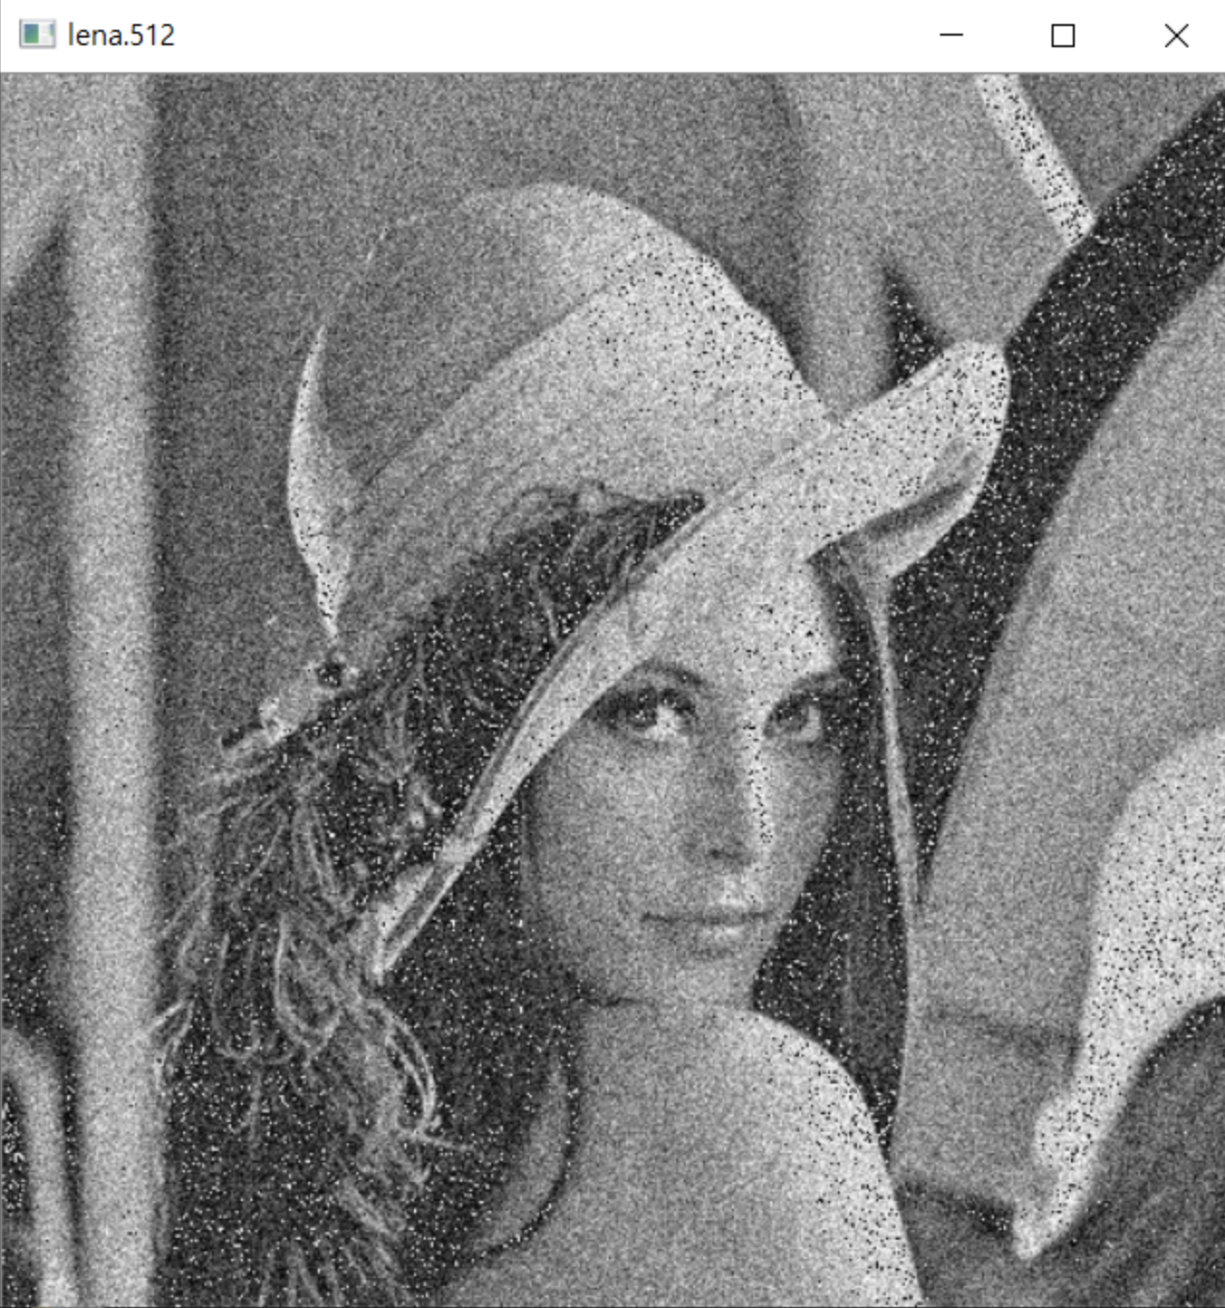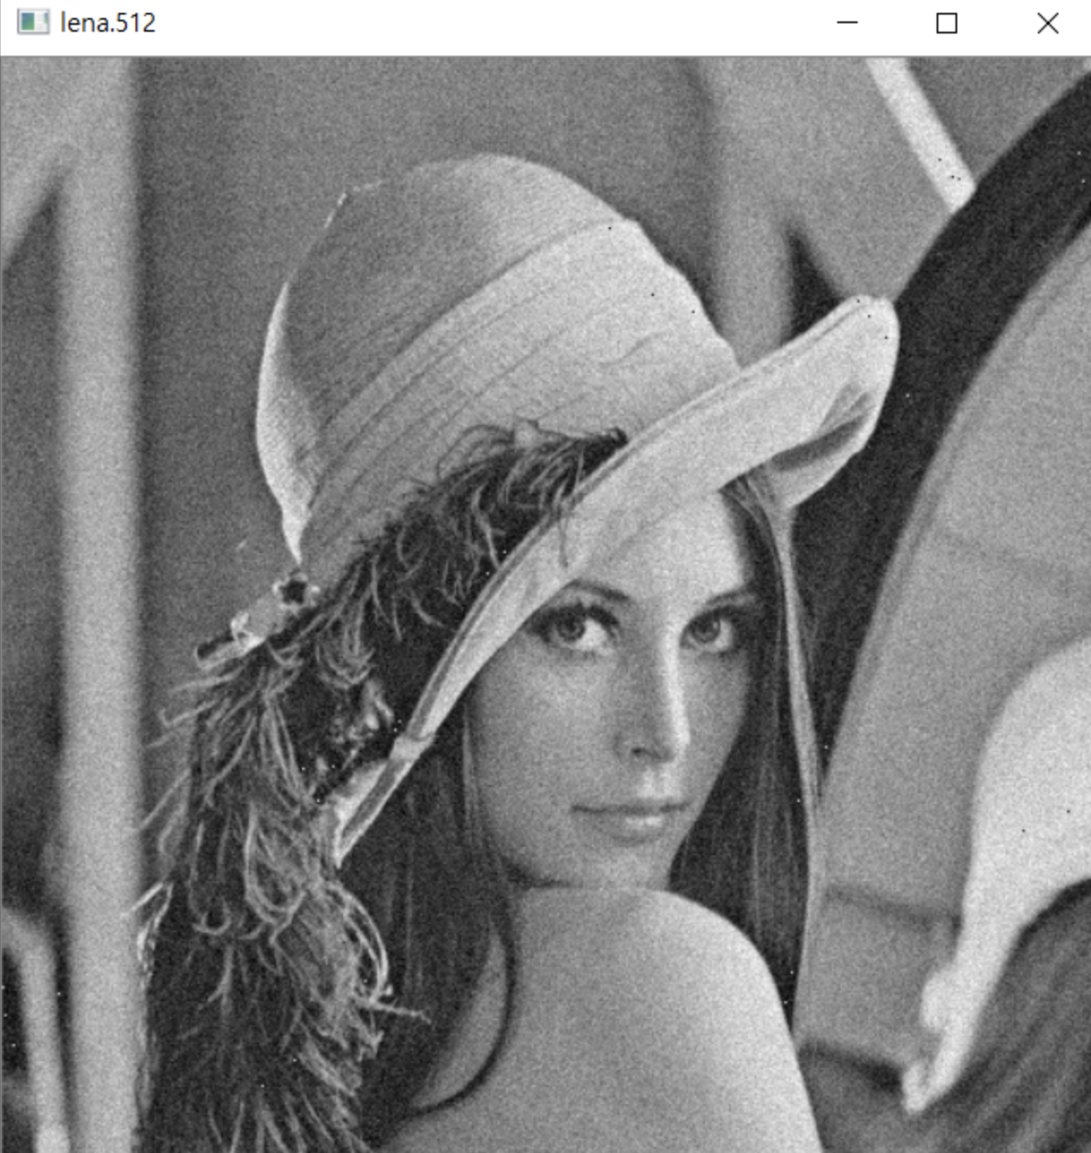

*num이 1일시 num이 5일시*

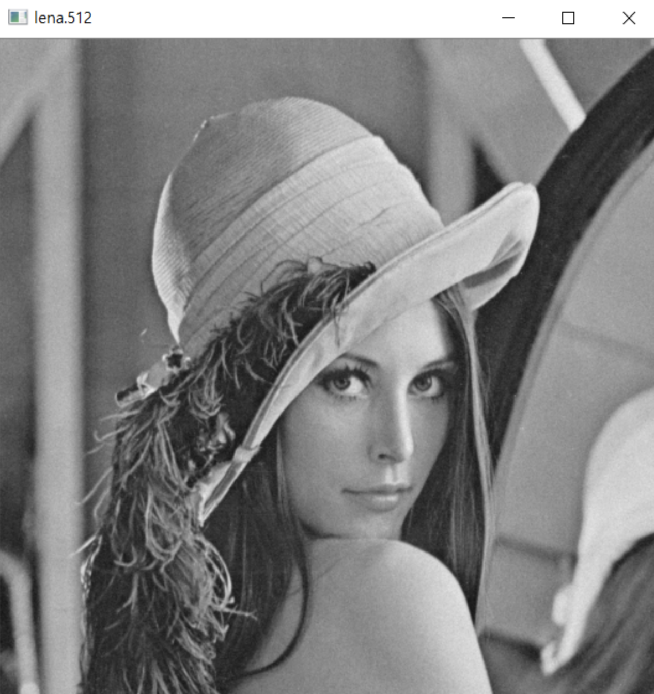

*num이 50장일시*

1. 원모양 모자이크 처리
   1. 소스코드

#include <iostream>  
  
#include<opencv\cv.h>  
#include<opencv\highgui.h>  
#include<opencv\cxcore.h>  
#include<stdio.h>  
  
#define **unsigned char** uchar  
  
uchar** uc_alloc(**int** size_x, **int** size_y)  
{  
  
 uchar** m;  
 **int** i;  
  
 **if** ((m = (uchar * *)calloc(size_y, **sizeof**(uchar*))) == NULL)  
 {  
 printf("uc_alloc error 1\7\n");  
 exit(0);  
 }  
  
 **for** (i = 0; i < size_y; i++)  
 **if** ((m[i] = (uchar*)calloc(size_x, **sizeof**(uchar))) == NULL) {  
 printf("uc_alloc error 2\7\n");  
 exit(0);  
  
 }  
 **return** m;  
}  
**void** read_ucmatrix(**int** size_x, **int** size_y, uchar** ucmatrix, **char**\* filename)  
{  
 **int** i;  
 FILE* f;  
 **if** ((fopen_s(&f, filename, "rb")) != NULL)  
 {  
 printf("%s File open Error! \n", filename);  
 exit(0);  
  
 }  
 **for** (i = 0; i < size_y; i++)  
 **if** (fread(ucmatrix[i], **sizeof**(uchar), size_x, f) != size_x)  
 {  
 printf("Data Read Error! \n");  
 exit(0);  
  
 }  
 fclose(f);  
}  
**void** write_ucmatrix(**int** size_x, **int** size_y, uchar** ucmatrix, **char**\* filename)  
{  
 **int** i;  
 FILE* f;  
  
 **if** ((fopen_s(&f, filename, "wb")) != NULL)  
 {  
 printf("%s File open Error! \n", filename);  
 exit(0);  
 }  
  
 **for** (i = 0; i < size_y; i++)  
 **if** (fwrite(ucmatrix[i], **sizeof**(uchar), size_x, f) != size_x)  
 {  
 printf("Data Write Error! \n");  
 exit(0);  
 }  
 fclose(f);  
}  
  
**void** mosaic(uchar** img, uchar** out, **int** Row, **int** Col, **int** Block) {  
 **int** i, j, x, y, tmp, count;  
 **for** (i = 0; i < Row; i += Block) {  
 **for** (j = 0; j < Col; j += Block) {  
 tmp = 0;  
 count = 0;  
 **for** (y = 0; y < Block; y++) {  
 **for** (x = 0; x < Block; x++) {  
 tmp += img[i + y][j + x];  
 count++;  
 }  
  
  
 tmp /= count;  
 **for** (y = 0; y < Block; y++) {  
 **for** (x = 0; x < Block; x++) {  
 out[i + y][j + x] = tmp;  
 }  
  
 }  
 }  
 }  
 }  
}  
  
**void** mosaicCircle(uchar** img, uchar** Result, **int** Row, **int** Col, **double** diameter, **int** Block)  
{  
 **int** i, j, x, y, tmp2, c;  
 **double** tmp, xSqure, ySqure;  
 uchar** rimg;  
  
 rimg = uc_alloc(Row, Col);  
 mosaic(img, rimg, Row, Col, Block);  
  
 **for** (i = 0; i < Row; i++)  
 **for** (j = 0; j < Col; j++)  
 {  
 ySqure = (abs(Row / 2 - i)) * (abs(Row / 2 - i));  
 xSqure = (abs(Col / 2 - j)) * (abs(Col / 2 - j));  
  
 tmp = sqrt(ySqure + xSqure);  
  
 **if** (tmp < diameter) Result[i][j] = rimg[i][j];  
 **else** Result[i][j] = img[i][j];  
 }  
}  
  
**int** main(**int** argc, **char**\* argv[])  
{  
  
 **int** i, j, circle_size, mosaic_value;  
 IplImage* cvImg;  
 CvSize imgSize;  
 uchar** img, ** result_img, ** result2_img, ** circle_img, ** circle2_img;  
  
 **if** (argc != 6)  
 {  
 printf("Exe imgData x_size y_size \n");  
 exit(0);  
 }  
  
 imgSize.width = atoi(argv[2]);  
 imgSize.height = atoi(argv[3]);  
 circle_size = atoi(argv[4]);  
 mosaic_value = atoi(argv[5]);  
  
 img = uc_alloc(imgSize.width, imgSize.height);  
 result_img = uc_alloc(imgSize.width, imgSize.height);  
 read_ucmatrix(imgSize.width, imgSize.height, img, argv[1]);  
  
 cvImg = cvCreateImage(imgSize, 8, 1);  
  
 mosaicCircle(img, result_img, imgSize.width, imgSize.height, circle_size , mosaic_value);  
  
 **for** (i = 0; i < imgSize.height; i++)  
 **for** (j = 0; j < imgSize.width; j++)  
 {  
 ((uchar*)(cvImg->imageData + cvImg->widthStep * i))[j] = result_img[i][j];  
 }  
  
 cvNamedWindow(argv[1], 1);  
 cvShowImage(argv[1], cvImg);  
  
 cvWaitKey(0);  
  
 cvDestroyWindow("image");  
 cvReleaseImage(&cvImg);  
  
 getchar();  
  
 **return** 0;  
  
}

* 1. 핵심코드

//중앙 원모양만큼 모자이크 하기  
//diameter는 원의 크기, block은 모자이크의 강도이다.  
**void** mosaicCircle(uchar** img, uchar** Result, **int** Row, **int** Col, **double** diameter, **int** Block)  
{  
 **int** i, j, x, y, tmp2, c;  
 **double** tmp, xSqure, ySqure;  
 //rimg이미지 생성  
 uchar** rimg;  
 rimg = uc_alloc(Row, Col);  
 //img를 모자이크하여 rimg로 저장  
 mosaic(img, rimg, Row, Col, Block);  
 //모든비트에 작업을 해준다.  
 **for** (i = 0; i < Row; i++)  
 **for** (j = 0; j < Col; j++)  
 {  
 // 공식을 통하여 원이 되는 좌표를 만들어 준다. r2 = x2 + y2  
 ySqure = (abs(Row / 2 - i)) * (abs(Row / 2 - i));  
 xSqure = (abs(Col / 2 - j)) * (abs(Col / 2 - j));  
 //루트를 씌어주는 함수 r = 루트 x2 + y2  
 tmp = sqrt(ySqure + xSqure);  
 //원 안쪽은 모자이크 작업  
 **if** (tmp < diameter) Result[i][j] = rimg[i][j];  
 //원 바깥쪽은 원본 이미지를 씌운다.  
 **else** Result[i][j] = img[i][j];  
 }  
}

* 1. 실행화면

cmd에서 imegeprocessing.exe lena.512 512 512 200 16 했을시

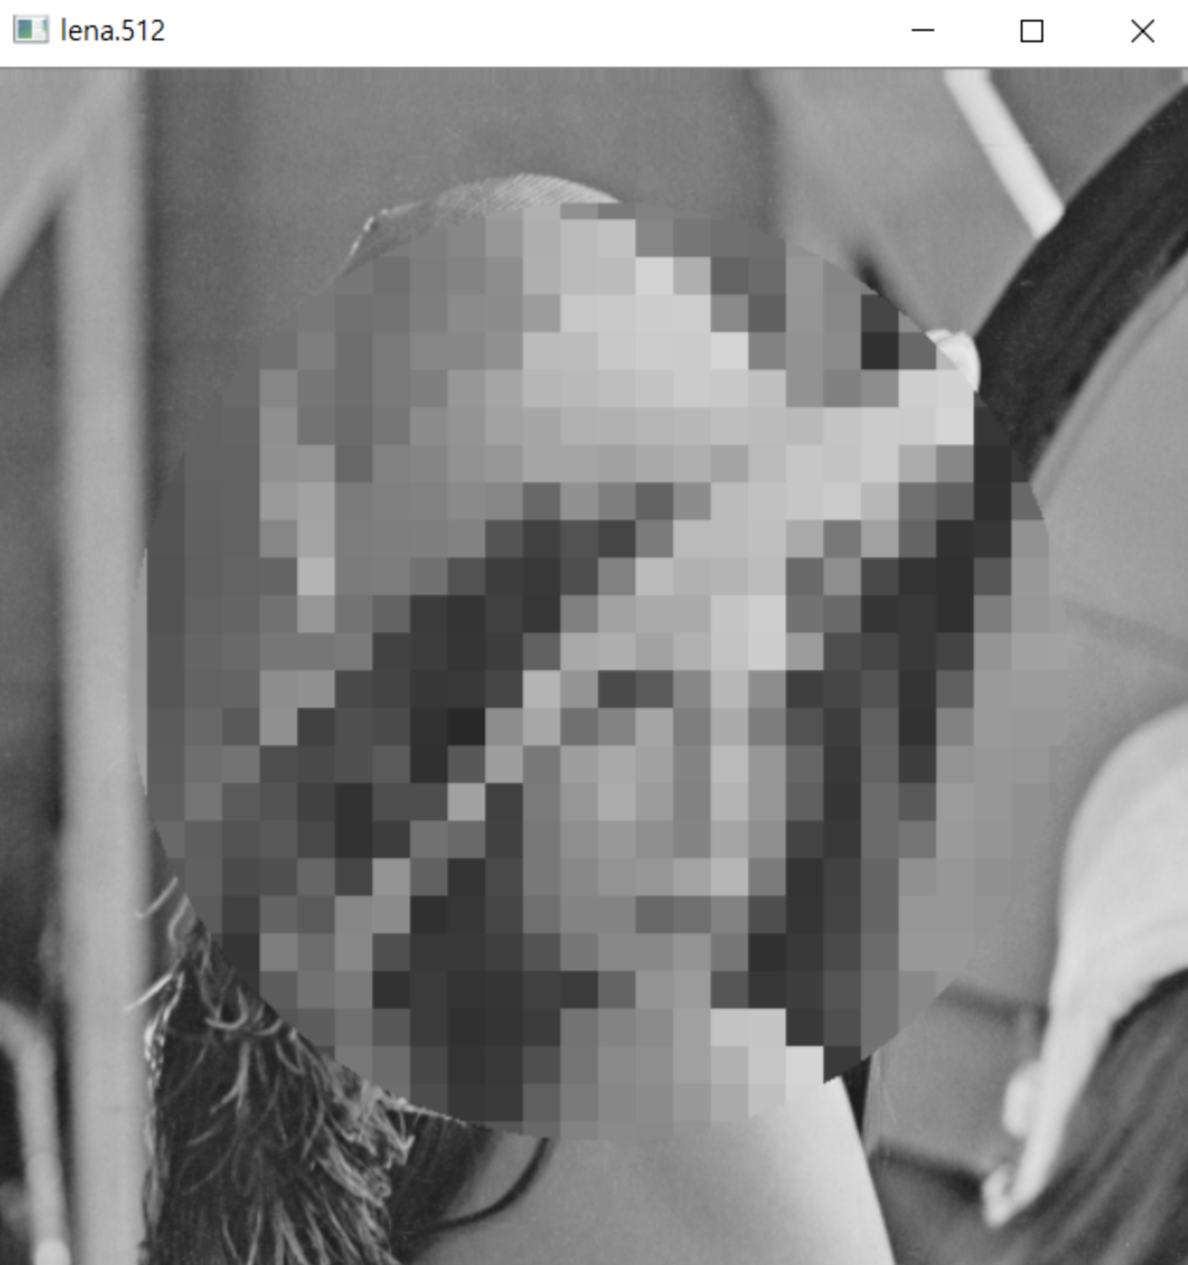

*원모양의 모자이크가 중앙에 생기는 것을 확인할 수 있다.*

1. 입력받는 위치에 원모자이크

#include <iostream>  
  
#include<opencv\cv.h>  
#include<opencv\highgui.h>  
#include<opencv\cxcore.h>  
#include<stdio.h>  
  
#define **unsigned char** uchar  
  
uchar** uc_alloc(**int** size_x, **int** size_y)  
{  
  
 uchar** m;  
 **int** i;  
  
 **if** ((m = (uchar * *)calloc(size_y, **sizeof**(uchar*))) == NULL)  
 {  
 printf("uc_alloc error 1\7\n");  
 exit(0);  
 }  
  
 **for** (i = 0; i < size_y; i++)  
 **if** ((m[i] = (uchar*)calloc(size_x, **sizeof**(uchar))) == NULL) {  
 printf("uc_alloc error 2\7\n");  
 exit(0);  
  
 }  
 **return** m;  
}  
**void** read_ucmatrix(**int** size_x, **int** size_y, uchar** ucmatrix, **char**\* filename)  
{  
 **int** i;  
 FILE* f;  
 **if** ((fopen_s(&f, filename, "rb")) != NULL)  
 {  
 printf("%s File open Error! \n", filename);  
 exit(0);  
  
 }  
 **for** (i = 0; i < size_y; i++)  
 **if** (fread(ucmatrix[i], **sizeof**(uchar), size_x, f) != size_x)  
 {  
 printf("Data Read Error! \n");  
 exit(0);  
  
 }  
 fclose(f);  
}  
**void** write_ucmatrix(**int** size_x, **int** size_y, uchar** ucmatrix, **char**\* filename)  
{  
 **int** i;  
 FILE* f;  
  
 **if** ((fopen_s(&f, filename, "wb")) != NULL)  
 {  
 printf("%s File open Error! \n", filename);  
 exit(0);  
 }  
  
 **for** (i = 0; i < size_y; i++)  
 **if** (fwrite(ucmatrix[i], **sizeof**(uchar), size_x, f) != size_x)  
 {  
 printf("Data Write Error! \n");  
 exit(0);  
 }  
 fclose(f);  
}  
  
**void** mosaic(uchar** img, uchar** out, **int** Row, **int** Col, **int** Block) {  
 **int** i, j, x, y, tmp, count;  
 **for** (i = 0; i < Row; i += Block) {  
 **for** (j = 0; j < Col; j += Block) {  
 tmp = 0;  
 count = 0;  
 **for** (y = 0; y < Block; y++) {  
 **for** (x = 0; x < Block; x++) {  
 tmp += img[i + y][j + x];  
 count++;  
 }  
  
  
 tmp /= count;  
 **for** (y = 0; y < Block; y++) {  
 **for** (x = 0; x < Block; x++) {  
 out[i + y][j + x] = tmp;  
 }  
  
 }  
 }  
 }  
 }  
}  
  
**void** mosaicCircle(uchar** img, uchar** Result, **int** Row, **int** Col, **int** circlewidth, **int** circleheight, **double** diameter, **int** Block)  
{  
 **int** i, j, x, y, tmp2, c;  
 **double** tmp, xSqure, ySqure;  
 uchar** rimg;  
  
 rimg = uc_alloc(Row, Col);  
 mosaic(img, rimg, Row, Col, Block);  
  
 **for** (i = 0; i < Row; i++)  
 **for** (j = 0; j < Col; j++)  
 {  
 ySqure = (abs(circlewidth / 2 - i)) * (abs(circlewidth / 2 - i));  
 xSqure = (abs(circleheight / 2 - j)) * (abs(circleheight / 2 - j));  
  
 tmp = sqrt(ySqure + xSqure);  
  
 **if** (tmp < diameter) Result[i][j] = rimg[i][j];  
 **else** Result[i][j] = img[i][j];  
 }  
}  
  
**int** main(**int** argc, **char**\* argv[])  
{  
  
 **int** i, j, circle_size, mosaic_value, sizewidth, sizeheight;  
 IplImage* cvImg;  
 CvSize imgSize;  
 uchar** img, ** result_img, ** result2_img, ** circle_img, ** circle2_img;  
  
 **if** (argc != 6)  
 {  
 printf("Exe imgData x_size y_size \n");  
 exit(0);  
 }  
  
 imgSize.*width* = atoi(argv[2]);  
 imgSize.*height* = atoi(argv[3]);  
 circle_size = atoi(argv[4]);  
 mosaic_value = atoi(argv[5]);  
  
 printf("넓이 입력 바랍니다 : ");  
 scanf_s("%d",&sizewidth);  
 printf("높이 입력 바랍니다 : ");  
 scanf_s("%d", &sizeheight);  
 img = uc_alloc(imgSize.*width*, imgSize.*height*);  
 result_img = uc_alloc(imgSize.*width*, imgSize.*height*);  
 read_ucmatrix(imgSize.*width*, imgSize.*height*, img, argv[1]);  
  
 cvImg = cvCreateImage(imgSize, 8, 1);  
  
 mosaicCircle(img, result_img, imgSize.*width*, imgSize.*height*, sizewidth*2, sizeheight*2, circle_size , mosaic_value);  
  
 **for** (i = 0; i < imgSize.*height*; i++)  
 **for** (j = 0; j < imgSize.*width*; j++)  
 {  
 ((uchar*)(cvImg->*imageData* + cvImg->*widthStep* * i))[j] = result_img[i][j];  
 }  
  
 cvNamedWindow(argv[1], 1);  
 cvShowImage(argv[1], cvImg);  
  
 cvWaitKey(0);  
  
 cvDestroyWindow("image");  
 cvReleaseImage(&cvImg);  
  
 getchar();  
  
 **return** 0;  
  
}

1. 히스토릭

#include <opencv/cv.h>  
#include <opencv/highgui.h>  
#include <stdio.h>  
#include <math.h>  
#include <stdlib.h>  
  
#define **unsigned char** uchar  
  
**int** histogram[256], cdfOfHisto[256], histogramEqual[256];  
  
uchar** uc_alloc(**int** size_x, **int** size_y)  
{  
  
 uchar** m;  
 **int** i;  
  
 **if** ((m = (uchar**)calloc(size_y, **sizeof**(uchar*))) == NULL)  
 {  
 printf("uc_alloc error 1\7\n");  
 exit(0);  
 }  
  
 **for** (i = 0; i < size_y; i++)  
 **if** ((m[i] = (uchar*)calloc(size_x, **sizeof**(uchar))) == NULL) {  
 printf("uc_alloc error 2\7\n");  
 exit(0);  
  
 }  
 **return** m;  
}  
  
**void** read_ucmatrix(**int** size_x, **int** size_y, uchar** ucmatrix, **char**\* filename)  
{  
 **int** i;  
 FILE* f;  
 **if** ((fopen_s(&f, filename, "rb")) != NULL)  
 {  
 printf("%s File open Error! \n", filename);  
 exit(0);  
  
 }  
 **for** (i = 0; i < size_y; i++)  
 **if** (fread(ucmatrix[i], **sizeof**(uchar), size_x, f) != size_x)  
 {  
 printf("Data Read Error! \n");  
 exit(0);  
  
 }  
 fclose(f);  
}  
  
**void** write_ucmatrix(**int** size_x, **int** size_y, uchar** ucmatrix, **char**\* filename)  
{  
 **int** i;  
 FILE* f;  
  
 **if** ((fopen_s(&f, filename, "wb")) != NULL)  
 {  
 printf("%s File open Error! \n", filename);  
 exit(0);  
 }  
  
 **for** (i = 0; i < size_y; i++)  
 **if** (fwrite(ucmatrix[i], **sizeof**(uchar), size_x, f) != size_x)  
 {  
 printf("Data Write Error! \n");  
 exit(0);  
 }  
 fclose(f);  
}  
  
**void** get_hist(uchar** img, **int** X_Size, **int** Y_Size) {  
 **int** i, j, tmp;  
 **double** tmp1;  
 **int** t, tp, range, hrange;  
 CvSize histoSize, cdfSize;  
 IplImage* imgHisto, * cdfImgHisto;  
  
 histoSize.*width* = 256;  
 histoSize.*height* = 256;  
  
 cdfSize.*width* = 256;  
 cdfSize.*height* = 256;  
  
 imgHisto = cvCreateImage(histoSize, 8, 1);  
 cdfImgHisto = cvCreateImage(cdfSize, 8, 1);  
  
 **for** (i = 0; i < histoSize.*height*; i++) {  
 **for** (j = 0; j < histoSize.*width*; j++) {  
 ((uchar*)(imgHisto->*imageData* + imgHisto->*widthStep* * i))[j] = 0;  
 }  
 }  
 **for** (i = 0; i < cdfSize.*height*; i++) {  
 **for** (j = 0; j < cdfSize.*width*; j++) {  
 ((uchar*)(cdfImgHisto->*imageData* + cdfImgHisto->*widthStep* * i))[j] = 0;  
 }  
 }  
  
 tp = X_Size * Y_Size;  
  
 **for** (i = 0; i < 256; i++)  
 histogram[i] = 0;  
  
 **for** (i = 0; i < Y_Size; i++)  
 **for** (j = 0; j < X_Size; j++)  
 histogram[img[i][j]]++;  
  
 // Find the maximum histogram value  
 tmp1 = 0;  
 **for** (i = 0; i < 256; ++i) {  
 tmp1 = tmp1 > histogram[i] ? tmp1 : histogram[i];  
 }  
  
 **for** (i = 0; i < 256; ++i) {  
 tmp = (**int**)255 * (histogram[i] / tmp1);  
 cvLine(imgHisto, cvPoint(i, 255), cvPoint(i, 255 - tmp), CV_RGB(255, 255, 255), 1, 8, 0);  
  
 }  
 cvShowImage("Histo Line", imgHisto);  
  
 cdfOfHisto[0] = histogram[0];  
  
 **for** (i = 0; i < 256; i++) {  
 cdfOfHisto[i] = cdfOfHisto[i - 1] + histogram[i];  
 }  
  
 //Draw CDF of Histogram  
 tmp1 = (**double**)cdfOfHisto[255];  
 **for** (i = 0; i < 256; i++) {  
 tmp = (**int**)255 * (cdfOfHisto[i] / tmp1);  
 cvLine(cdfImgHisto, cvPoint(i, 255), cvPoint(i, 255 - tmp), CV_RGB(255, 255, 255), 1, 8, 0);  
 }  
  
 cvShowImage("Original CDF of Histogram", cdfImgHisto);  
  
 range = cdfOfHisto[255] - cdfOfHisto[0];  
 printf("%d %d\n", tp, range);  
 histogramEqual[0] = 0;  
  
 **for** (i = 1; i < 256; ++i) {  
 t = (**int**)ceil(((cdfOfHisto[i] - cdfOfHisto[0]) * 255.0) / range);  
 histogramEqual[i] = (t < 0) ? 0 : (t > 255) ? 255 : t;  
 }  
  
 cvReleaseImage(&imgHisto);  
 cvReleaseImage(&cdfImgHisto);  
 **for** (i = 0; i < Y_Size; ++i)  
 **for** (j = 0; j < X_Size; ++j)  
 img[i][j] = histogramEqual[img[i][j]];  
  
}  
  
**void** get_hist1(uchar** img, **int** X_Size, **int** Y_Size) {  
 **int** i, j, tmp;  
 **double** tmp1;  
 **int** t, tp, range, hrange;  
 CvSize histoSize, cdfSize;  
 IplImage* imgHisto, * cdfImgHisto;  
  
 histoSize.*width* = 256;  
 histoSize.*height* = 256;  
  
 cdfSize.*width* = 256;  
 cdfSize.*height* = 256;  
  
 imgHisto = cvCreateImage(histoSize, 8, 1);  
 cdfImgHisto = cvCreateImage(cdfSize, 8, 1);  
  
 **for** (i = 0; i < histoSize.*height*; i++) {  
 **for** (j = 0; j < histoSize.*width*; j++) {  
 ((uchar*)(imgHisto->*imageData* + imgHisto->*widthStep* * i))[j] = 0;  
 }  
 }  
 **for** (i = 0; i < cdfSize.*height*; i++) {  
 **for** (j = 0; j < cdfSize.*width*; j++) {  
 ((uchar*)(cdfImgHisto->*imageData* + cdfImgHisto->*widthStep* * i))[j] = 0;  
 }  
 }  
  
 tp = X_Size * Y_Size;  
  
 **for** (i = 0; i < 256; i++)  
 histogram[i] = 0;  
  
 **for** (i = 0; i < Y_Size; i++)  
 **for** (j = 0; j < X_Size; j++)  
 histogram[img[i][j]]++;  
  
 // Find the maximum histogram value  
 tmp1 = 0;  
 **for** (i = 0; i < 256; ++i) {  
 tmp1 = tmp1 > histogram[i] ? tmp1 : histogram[i];  
 }  
  
 **for** (i = 0; i < 256; ++i) {  
 tmp = (**int**)255 * (histogram[i] / tmp1);  
 cvLine(imgHisto, cvPoint(i, 255), cvPoint(i, 255 - tmp), CV_RGB(255, 255, 255), 1, 8, 0);  
  
 }  
 cvShowImage("Histo Equal", imgHisto);  
  
 cdfOfHisto[0] = histogram[0];  
  
 **for** (i = 0; i < 256; i++) {  
 cdfOfHisto[i] = cdfOfHisto[i - 1] + histogram[i];  
 }  
  
 //Draw CDF of Histogram  
 tmp1 = (**double**)cdfOfHisto[255];  
 **for** (i = 0; i < 256; i++) {  
 tmp = (**int**)255 * (cdfOfHisto[i] / tmp1);  
 cvLine(cdfImgHisto, cvPoint(i, 255), cvPoint(i, 255 - tmp), CV_RGB(255, 255, 255), 1, 8, 0);  
 }  
  
 cvShowImage("CDF of Histogram", cdfImgHisto);  
  
 range = cdfOfHisto[255] - cdfOfHisto[0];  
 printf("%d %d\n", tp, range);  
 histogramEqual[0] = 0;  
  
 **for** (i = 1; i < 256; ++i) {  
 t = (**int**)ceil(((cdfOfHisto[i] - cdfOfHisto[0]) * 255.0) / range);  
 histogramEqual[i] = (t < 0) ? 0 : (t > 255) ? 255 : t;  
 }  
  
 cvReleaseImage(&imgHisto);  
 cvReleaseImage(&cdfImgHisto);  
 **for** (i = 0; i < Y_Size; ++i)  
 **for** (j = 0; j < X_Size; ++j)  
 img[i][j] = histogramEqual[img[i][j]];  
  
}  
  
**int** main(**int** argc, **char**\* argv[])  
{  
  
 **int** i, j;  
 IplImage* cvImg;  
 CvSize imgSize;  
 uchar** img;  
  
 **if** (argc != 4)  
 {  
 printf("Exe imgData x_size y_size \n");  
 exit(0);  
 }  
  
 imgSize.*width* = atoi(argv[2]);  
 imgSize.*height* = atoi(argv[3]);  
 img = uc_alloc(imgSize.*width*, imgSize.*height*);  
 read_ucmatrix(imgSize.*width*, imgSize.*height*, img, argv[1]);  
 cvImg = cvCreateImage(imgSize, 8, 1);  
  
 **for** (i = 0; i < imgSize.*height*; i++)  
 **for** (j = 0; j < imgSize.*width*; j++)  
 {  
  
 ((uchar*)(cvImg->*imageData* + cvImg->*widthStep* * i))[j] = img[i][j];  
  
 }  
  
 cvNamedWindow(argv[1], 1);  
 cvShowImage(argv[1], cvImg);  
  
 get_hist(img, imgSize.*width*, imgSize.*height*);  
  
 **for** (i = 0; i < imgSize.*height*; i++)  
 **for** (j = 0; j < imgSize.*width*; j++)  
 {  
  
 ((uchar*)(cvImg->*imageData* + cvImg->*widthStep* * i))[j] = img[i][j];  
  
 }  
  
 cvShowImage("HistoGram Equalizer...", cvImg);  
 get_hist1(img, imgSize.*width*, imgSize.*height*);  
  
 cvWaitKey(0);  
 cvDestroyWindow("image");  
 cvReleaseImage(&cvImg);  
  
 getchar();  
  
 **return** 0;  
  
}

1. 콘트라스트 스트레칭

#include <opencv/cv.h>  
#include <opencv/highgui.h>  
#include <stdio.h>  
#include <math.h>  
#include <stdlib.h>  
  
#define **unsigned char** uchar  
**int** histogram[256], cdfOfHisto[256], histogramEqual[256];  
  
uchar** uc_alloc(**int** size_x, **int** size_y)  
{  
 uchar** m;  
 **int** i;  
  
 **if** ((m = (uchar**)calloc(size_y, **sizeof**(uchar*))) == NULL)  
 {  
 printf("uc_alloc error 1\7\n");  
 exit(0);  
 }  
  
 **for** (i = 0; i < size_y; i++)  
 **if** ((m[i] = (uchar*)calloc(size_x, **sizeof**(uchar))) == NULL)  
 {  
 printf("uc_alloc error 2\7\n");  
 exit(0);  
 }  
  
 **return** m;  
}  
  
**void** read_unmatrix(**int** size_x, **int** size_y, uchar** ucmatrix, **char**\* filename)  
{  
  
 **int** i;  
 FILE* f;  
  
 **if** ((fopen_s(&f, filename, "rb")) != NULL)  
 {  
 printf("%s File open Error!\n", filename);  
 exit(0);  
 }  
  
 **for** (i = 0; i < size_y; i++)  
 **if** (fread(ucmatrix[i], **sizeof**(uchar), size_x, f) != size_x)  
 {  
 printf("Data Read Error!\n");  
 exit(0);  
 }  
  
 fclose(f);  
}  
  
**void** write_ucmatrix(**int** size_x, **int** size_y, uchar** ucmatrix, **char**\* filename)  
{  
 **int** i;  
 FILE* f;  
  
 **if** ((fopen_s(&f, filename, "wb")) != NULL)  
 {  
 printf("%s File open Error\n", filename);  
 exit(0);  
 }  
  
 **for** (i = 0; i < size_y; i++)  
 **if** (fwrite(ucmatrix[i], **sizeof**(uchar), size_x, f) != size_x)  
 {  
 printf("Data Write Error!\n");  
 exit(0);  
 }  
 fclose(f);  
}  
  
**void** get_hist1(uchar** img, **int** X_Size, **int** Y_Size)  
{  
 **int** i, j, tmp;  
 **double** tmp1;  
 **int** t, tp, range, hrange;  
 CvSize histoSize, cdfSize;  
 IplImage* imgHisto, * cdfImgHisto;  
  
 histoSize.*width* = 256;  
 histoSize.*height* = 256;  
  
 cdfSize.*width* = 256;  
 cdfSize.*height* = 256;  
  
 imgHisto = cvCreateImage(histoSize, 8, 1);  
 cdfImgHisto = cvCreateImage(cdfSize, 8, 1);  
  
 **for** (i = 0; i < histoSize.*height*; i++)  
 **for** (j = 0; j < histoSize.*width*; j++)  
 {  
 ((uchar*)(imgHisto->*imageData* + imgHisto->*widthStep* * i))[j] = 0;  
 }  
 **for** (i = 0; i < cdfSize.*height*; i++)  
 **for** (j = 0; j < histoSize.*width*; j++)  
 {  
 ((uchar*)(cdfImgHisto->*imageData* + cdfImgHisto->*widthStep* * i))[j] = 0;  
 }  
  
 tp = X_Size * Y_Size;  
  
 **for** (i = 0; i < 256; i++)  
 histogram[i] = 0;  
  
 **for** (i = 0; i < Y_Size; i++)  
 **for** (j = 0; j < X_Size; j++)  
 histogram[img[i][j]]++;  
  
 // Find the maximum histogram value  
 tmp1 = 0;  
 **for** (i = 0; i < 256; ++i)  
 {  
 tmp1 = tmp1 > histogram[i] ? tmp1 : histogram[i];  
 }  
  
 **for** (i = 0; i < 256; ++i)  
 {  
 tmp = (**int**)255 * (histogram[i] / tmp1);  
  
 cvLine(imgHisto, cvPoint(i, 255), cvPoint(i, 255 - tmp), CV_RGB(255, 255, 255), 1, 8, 0);  
 }  
  
 cvShowImage("Histo Equal ", imgHisto);  
  
 cdfOfHisto[0] = histogram[0];  
 **for** (i = 1; i < 256; i++)  
 {  
 cdfOfHisto[i] = cdfOfHisto[i - 1] + histogram[i];  
 }  
 // Draw the CDF of Histogram  
 tmp1 = (**double**)cdfOfHisto[255];  
 **for** (i = 0; i < 256; ++i)  
 {  
 tmp = (**int**)255 * (cdfOfHisto[i] / tmp1);  
  
 cvLine(cdfImgHisto, cvPoint(i, 255), cvPoint(i, 256 - tmp), CV_RGB(255, 255, 255), 1, 8, 0);  
 }  
  
 cvShowImage("CDF of Histogram ", cdfImgHisto);  
  
 range = cdfOfHisto[255] - cdfOfHisto[0];  
 // printf("%d" %d \n", tp, range);  
 histogramEqual[0] = 0;  
 **for** (i = 0; i < 256; ++i) {  
 t = (**int**)ceil(((cdfOfHisto[i] - cdfOfHisto[0]) * 255.0) / range);  
 histogramEqual[i] = (t < 0) ? 0 : (t > 255) ? 255 : t;  
 }  
  
 cvReleaseImage(&imgHisto);  
 cvReleaseImage(&cdfImgHisto);  
 **for** (i = 0; i < Y_Size; ++i)  
 **for** (j = 0; j < X_Size; ++j)  
 img[i][j] = histogramEqual[img[i][j]];  
}  
  
**void** get_hist(uchar** img, **int** X_Size, **int** Y_Size)  
{  
 **int** i, j, tmp;  
 **double** tmp1;  
 **int** t, tp, range, hrange;  
 CvSize histoSize, cdfSize;  
 IplImage* imgHisto, * cdfImgHisto;  
  
 histoSize.*width* = 256;  
 histoSize.*height* = 256;  
  
 cdfSize.*width* = 256;  
 cdfSize.*height* = 256;  
  
 imgHisto = cvCreateImage(histoSize, 8, 1);  
 cdfImgHisto = cvCreateImage(cdfSize, 8, 1);  
  
 **for** (i = 0; i < histoSize.*height*; i++)  
 **for** (j = 0; j < histoSize.*width*; j++)  
 {  
 ((uchar*)(imgHisto->*imageData* + imgHisto->*widthStep* * i))[j] = 0;  
 }  
  
 **for** (i = 0; i < cdfSize.*height*; i++)  
 **for** (j = 0; j < cdfSize.*width*; j++)  
 {  
 ((uchar*)(cdfImgHisto->*imageData* + cdfImgHisto->*widthStep* * i))[j] = 0;  
 }  
  
 tp = X_Size * Y_Size;  
  
 **for** (i = 0; i < 256; i++)  
 histogram[i] = 0;  
  
 **for** (i = 0; i < Y_Size; i++)  
 **for** (j = 0; j < X_Size; j++)  
 histogram[img[i][j]]++;  
 /*아래쪽으로 계속*/  
 tmp1 = 0;  
  
 **for** (i = 0; i < 256; ++i)  
 {  
 tmp1 = tmp1 > histogram[i] ? tmp1 : histogram[i];  
 }  
 **for** (i = 0; i < 256; ++i)  
 {  
 tmp = (**int**)255 * (histogram[i] / tmp1);  
 cvLine(imgHisto, cvPoint(i, 255), cvPoint(i, 255 - tmp), CV_RGB(255, 255, 255), 1, 8, 0);  
 }  
 cvShowImage("Histo Line", imgHisto);  
 cdfOfHisto[0] = histogram[0];  
 **for** (i = 0; i < 256; i++)  
 cdfOfHisto[i] = cdfOfHisto[i - 1] + histogram[i];  
  
 //Draw the CDF of Histogram  
 tmp1 = (**double**)cdfOfHisto[255];  
 **for** (i = 0; i < 256; ++i)  
 {  
 tmp = (**int**)255 * (cdfOfHisto[i] / tmp1);  
  
 cvLine(cdfImgHisto, cvPoint(i, 255), cvPoint(i, 256 - tmp), CV_RGB(255, 255, 255), 1, 8, 0);  
 }  
 cvShowImage("Original CDF of Histogram", cdfImgHisto);  
  
 range = cdfOfHisto[255] - cdfOfHisto[0];  
 histogramEqual[0] = 0;  
 **for** (i = 1; i < 256; ++i) {  
 t = (**int**)ceil(((cdfOfHisto[i] - cdfOfHisto[0]) * 255.0) / range);  
 histogramEqual[i] = (t < 0) ? 0 : (t > 255) ? 255 : t;  
 }  
 cvReleaseImage(&imgHisto);  
 **for** (i = 0; i < Y_Size; ++i)  
 **for** (j = 0; j < X_Size; ++j)  
 img[i][j] = histogramEqual[img[i][j]];  
}  
  
  
**void** PowImg(uchar** img, uchar** Result, **int** Row, **int** Col, **double** gamma)  
{  
 **int** i, j;  
 **double** tmp;  
  
 **for** (i = 0; i < Row; i++)  
 **for** (j = 0; j < Col; j++)  
 {  
 tmp = pow(img[j][i] / 255., 1 / gamma);  
  
 **if** (tmp * 255 > 255)tmp = 1;  
 **else if** (tmp * 255 < 0) tmp = 0;  
  
 tmp = tmp * 255;  
  
 Result[j][i] = tmp;  
 }  
}  
  
**void** get_Match(uchar** img, **int** x_size, **int** y_size, **int** histogram[256], **int** histogramSpec[256], **int** histogramMatch[256])  
{  
 **int** i, j, tmp, matchz = 0;  
 **float** diff;  
 printf("Start HistoGram Specification \n");  
 **for** (i = 0; i < 256; i++)  
 {  
 histogramMatch[i] = 0;  
 **for** (j = 0; j < 256; j++)  
 {  
 **if** ((i - histogramSpec[j]) > 0)  
 {  
 histogramMatch[i] = j;  
 }  
 }  
 }  
 /*  
 // Inverse Processing of expected Histogram  
 for(i = 0; i < 256; ++i){  
 diff = abs(i - histogramSpec[0]);  
 matchz = 0;  
 for(j = 0; j < 256; ++j)  
 {  
 if(abs(i - histogramSpec[j]) < diff)  
 {  
 diff = abs(i - histogramSpec[j]);  
 matchz = j;  
 }  
 }  
 histogramMatch[i] = (uchar)matchz;  
 }  
 */  
 **for** (i = 0; i < y_size; ++i)  
 **for** (j = 0; j < x_size; ++j)  
 img[i][j] = histogramMatch[img[i][j]];  
}  
  
**void** contrastStretching(uchar** img, uchar** result_img, **int** x_size, **int** y_size)  
{  
 **int** i, j, histogram[256];  
 **int** min = 255, max = 0;  
 uchar LUT[256];  
 **double** scaleFactor, tmp;  
 **for** (i = 0; i < 256; i++)  
 histogram[i] = 0;  
  
 **for** (i = 0; i < y_size; i++)  
 **for** (j = 0; j < x_size; j++)  
 {  
 histogram[img[i][j]]++;  
 }  
  
 **for** (i = 0; i < 256; i++)  
 **if** (histogram[i])  
 {  
 min = i;  
 **break**;  
 }  
 **for** (i = 255; i >= 0; i--)  
 **if** (histogram[i])  
 {  
 max = i;  
 **break**;  
 }  
  
 printf(" Low Threshold is %d High Threshold is %d \n", min, max);  
 **for** (i = 0; i < min; i++)  
 LUT[i] = 0;  
 **for** (i = 255; i >= max; i--)  
 LUT[i] = 255;  
  
 scaleFactor = 255.0 / (**double**)(max - min);  
  
 **for** (i = min; i < max; i++)  
 {  
 tmp = (i - min) * scaleFactor;  
  
 **if** (tmp < 0) tmp = 0;  
 **if** (tmp > 255) tmp = 255;  
 LUT[i] = (uchar)tmp;  
 }  
  
 **for** (i = 0; i < y_size; i++)  
 **for** (j = 0; j < x_size; j++)  
 result_img[i][j] = LUT[img[i][j]];  
  
}  
  
**int** main(**int** argc, **char**\* argv[])  
{  
 **int** i, j;  
 IplImage* cvImg;  
 CvSize imgSize;  
 uchar** img, ** pow_img, ** result_img;  
 **if** (argc != 4)  
 {  
 printf("실행완료 \n");  
 exit(0);  
 }  
 imgSize.*width* = atoi(argv[2]);  
 imgSize.*height* = atoi(argv[3]);  
 img = uc_alloc(imgSize.*width*, imgSize.*height*);  
 pow_img = uc_alloc(imgSize.*width*, imgSize.*height*);  
 result_img = uc_alloc(imgSize.*width*, imgSize.*height*);  
 read_unmatrix(imgSize.*width*, imgSize.*height*, img, argv[1]);  
  
 cvImg = cvCreateImage(imgSize, 8, 1);  
  
 PowImg(img, pow_img, imgSize.*width*, imgSize.*height*, 3.45);  
 contrastStretching(pow_img, result_img, imgSize.*width*, imgSize.*height*);  
  
 **for** (i = 0; i < imgSize.*height*; i++)  
 **for** (j = 0; j < imgSize.*width*; j++)  
 {  
 ((uchar*)(cvImg->*imageData* + cvImg->*widthStep* * i))[j] = img[i][j];  
 }  
 cvNamedWindow(argv[1], 1);  
  
 cvShowImage(argv[1], cvImg);  
 get_hist(img, imgSize.*width*, imgSize.*height*);  
  
  
 **for** (i = 0; i < imgSize.*height*; i++)  
 **for** (j = 0; j < imgSize.*width*; j++)  
 {  
 ((uchar*)(cvImg->*imageData* + cvImg->*widthStep* * i))[j] = result_img[i][j];  
 }  
 cvShowImage("Histogram contrastStretching...", cvImg);  
 get_hist1(result_img, imgSize.*width*, imgSize.*height*);  
  
  
 cvWaitKey(0);  
 cvDestroyWindow(argv[1]);  
 cvReleaseImage(&cvImg);  
 **return** 0;  
}

1. 3-2

#include <opencv/cv.h>  
#include <opencv/highgui.h>  
#include <stdio.h>  
#include <math.h>  
#include <stdlib.h>  
  
#define **unsigned char** uchar  
**int** histogram[256], cdfOfHisto[256], histogramEqual[256];  
  
uchar** uc_alloc(**int** size_x, **int** size_y)  
{  
 uchar** m;  
 **int** i;  
  
 **if** ((m = (uchar * *)calloc(size_y, **sizeof**(uchar*))) == NULL)  
 {  
 printf("uc_alloc error 1\7\n");  
 exit(0);  
 }  
  
 **for** (i = 0; i < size_y; i++)  
 **if** ((m[i] = (uchar*)calloc(size_x, **sizeof**(uchar))) == NULL)  
 {  
 printf("uc_alloc error 2\7\n");  
 exit(0);  
 }  
  
 **return** m;  
}  
  
**void** read_unmatrix(**int** size_x, **int** size_y, uchar** ucmatrix, **char**\* filename)  
{  
  
 **int** i;  
 FILE* f;  
  
 **if** ((fopen_s(&f, filename, "rb")) != NULL)  
 {  
 printf("%s File open Error!\n", filename);  
 exit(0);  
 }  
  
 **for** (i = 0; i < size_y; i++)  
 **if** (fread(ucmatrix[i], **sizeof**(uchar), size_x, f) != size_x)  
 {  
 printf("Data Read Error!\n");  
 exit(0);  
 }  
  
 fclose(f);  
}  
  
**void** write_ucmatrix(**int** size_x, **int** size_y, uchar** ucmatrix, **char**\* filename)  
{  
 **int** i;  
 FILE* f;  
  
 **if** ((fopen_s(&f, filename, "wb")) != NULL)  
 {  
 printf("%s File open Error\n", filename);  
 exit(0);  
 }  
  
 **for** (i = 0; i < size_y; i++)  
 **if** (fwrite(ucmatrix[i], **sizeof**(uchar), size_x, f) != size_x)  
 {  
 printf("Data Write Error!\n");  
 exit(0);  
 }  
 fclose(f);  
}  
  
**void** get_hist1(uchar** img, **int** X_Size, **int** Y_Size)  
{  
 **int** i, j, tmp;  
 **double** tmp1;  
 **int** t, tp, range, hrange;  
 CvSize histoSize, cdfSize;  
 IplImage* imgHisto, * cdfImgHisto;  
  
 histoSize.*width* = 256;  
 histoSize.*height* = 256;  
  
 cdfSize.*width* = 256;  
 cdfSize.*height* = 256;  
  
 imgHisto = cvCreateImage(histoSize, 8, 1);  
 cdfImgHisto = cvCreateImage(cdfSize, 8, 1);  
  
 **for** (i = 0; i < histoSize.*height*; i++)  
 **for** (j = 0; j < histoSize.*width*; j++)  
 {  
 ((uchar*)(imgHisto->*imageData* + imgHisto->*widthStep* * i))[j] = 0;  
 }  
 **for** (i = 0; i < cdfSize.*height*; i++)  
 **for** (j = 0; j < histoSize.*width*; j++)  
 {  
 ((uchar*)(cdfImgHisto->*imageData* + cdfImgHisto->*widthStep* * i))[j] = 0;  
 }  
  
 tp = X_Size * Y_Size;  
  
 **for** (i = 0; i < 256; i++)  
 histogram[i] = 0;  
  
 **for** (i = 0; i < Y_Size; i++)  
 **for** (j = 0; j < X_Size; j++)  
 histogram[img[i][j]]++;  
  
 // Find the maximum histogram value  
 tmp1 = 0;  
 **for** (i = 0; i < 256; ++i)  
 {  
 tmp1 = tmp1 > histogram[i] ? tmp1 : histogram[i];  
 }  
  
 **for** (i = 0; i < 256; ++i)  
 {  
 tmp = (**int**)255 * (histogram[i] / tmp1);  
  
 cvLine(imgHisto, cvPoint(i, 255), cvPoint(i, 255 - tmp), CV_RGB(255, 255, 255), 1, 8, 0);  
 }  
  
 cvShowImage("#3", imgHisto);  
  
 cdfOfHisto[0] = histogram[0];  
 **for** (i = 1; i < 256; i++)  
 {  
 cdfOfHisto[i] = cdfOfHisto[i - 1] + histogram[i];  
 }  
 // Draw the CDF of Histogram  
 tmp1 = (**double**)cdfOfHisto[255];  
 **for** (i = 0; i < 256; ++i)  
 {  
 tmp = (**int**)255 * (cdfOfHisto[i] / tmp1);  
  
 cvLine(cdfImgHisto, cvPoint(i, 255), cvPoint(i, 256 - tmp), CV_RGB(255, 255, 255), 1, 8, 0);  
 }  
  
 cvShowImage("#4", cdfImgHisto);  
  
 range = cdfOfHisto[255] - cdfOfHisto[0];  
 // printf("%d" %d \n", tp, range);  
 histogramEqual[0] = 0;  
 **for** (i = 0; i < 256; ++i) {  
 t = (**int**)ceil(((cdfOfHisto[i] - cdfOfHisto[0]) * 255.0) / range);  
 histogramEqual[i] = (t < 0) ? 0 : (t > 255) ? 255 : t;  
 }  
  
 cvReleaseImage(&imgHisto);  
 cvReleaseImage(&cdfImgHisto);  
 **for** (i = 0; i < Y_Size; ++i)  
 **for** (j = 0; j < X_Size; ++j)  
 img[i][j] = histogramEqual[img[i][j]];  
}  
  
**void** get_hist(uchar** img,uchar** result_img, **int** X_Size, **int** Y_Size)  
{  
 **int** i, j, tmp;  
 **double** tmp1;  
 **int** t, tp, range, hrange;  
 CvSize histoSize, cdfSize;  
 IplImage* imgHisto, * cdfImgHisto;  
  
 histoSize.*width* = 256; // Histogram Size  
 histoSize.*height* = 256;  
  
 cdfSize.*width* = 256; // Cdf Size  
 cdfSize.*height* = 256;  
  
 imgHisto = cvCreateImage(histoSize, 8, 1); // Histogram image Window Create  
 cdfImgHisto = cvCreateImage(cdfSize, 8, 1); // Cdf image Window Create  
  
 **for** (i = 0; i < histoSize.*height*; i++) // Histogram Initalized  
 **for** (j = 0; j < histoSize.*width*; j++)  
 {  
 ((uchar*)(imgHisto->*imageData* + imgHisto->*widthStep* * i))[j] = 0;  
 }  
  
 **for** (i = 0; i < cdfSize.*height*; i++) //Cdf Initialized  
 **for** (j = 0; j < cdfSize.*width*; j++)  
 {  
 ((uchar*)(cdfImgHisto->*imageData* + cdfImgHisto->*widthStep* * i))[j] = 0;  
 }  
  
 tp = X_Size * Y_Size;  
  
 **for** (i = 0; i < 256; i++)  
 histogram[i] = 0; //Global Variable Initialized  
  
 **for** (i = 0; i < Y_Size; i++)  
 **for** (j = 0; j < X_Size; j++)  
 histogram[img[i][j]]++; // Input Image pixel to Histogram  
  
 tmp1 = 0;  
  
 **for** (i = 0; i < 256; ++i)  
 {  
 tmp1 = tmp1 > histogram[i] ? tmp1 : histogram[i]; // Compare tmp & histogram (tmp>histogram)  
 }  
 **for** (i = 0; i < 256; ++i)  
 {  
 tmp = (**int**)255 * (histogram[i] / tmp1);  
 cvLine(imgHisto, cvPoint(i, 255), cvPoint(i, 255 - tmp), CV_RGB(255, 255, 255), 1, 8, 0); // Draw Histogram  
 }  
 cvShowImage("#1", imgHisto);  
  
 cdfOfHisto[0] = histogram[0];  
  
 **for** (i = 0; i < 256; i++)  
 cdfOfHisto[i] = cdfOfHisto[i - 1] + histogram[i]; // Histogram을 이용해 누적분포함수 구하기  
  
  
 tmp1 = (**double**)cdfOfHisto[255];  
 **for** (i = 0; i < 256; ++i)  
 {  
 tmp = (**int**)255 * (cdfOfHisto[i] / tmp1);  
  
 cvLine(cdfImgHisto, cvPoint(i, 255), cvPoint(i, 256 - tmp), CV_RGB(255, 255, 255), 1, 8, 0); // Draw 누적분포함수  
 }  
 cvShowImage("#2", cdfImgHisto);  
  
 range = cdfOfHisto[255] - cdfOfHisto[0]; // 누적분포함수 Range  
 histogramEqual[0] = 0;  
 **for** (i = 1; i < 256; ++i) {  
 t = (**int**)ceil(((cdfOfHisto[i] - cdfOfHisto[0]) * 255.0) / range);  
 histogramEqual[i] = (t < 0) ? 0 : (t > 255) ? 255 : t;  
 }  
 cvReleaseImage(&imgHisto);  
 **for** (i = 0; i < Y_Size; ++i)  
 **for** (j = 0; j < X_Size; ++j)  
 result_img[i][j] = histogramEqual[img[i][j]]; //역함수를 이용해 평활화 영상결과를 img에 넣음  
}  
  
**int** main(**int** argc, **char**\* argv[])  
{  
 **int** i, j;  
 IplImage* cvImg;  
 CvSize imgSize;  
 uchar** img, ** result_img;  
 **if** (argc != 4)  
 {  
 printf("실행완료 \n");  
 exit(0);  
 }  
 imgSize.*width* = atoi(argv[2]); // Input Image width Size  
 imgSize.*height* = atoi(argv[3]); // Input Image height Size  
 img = uc_alloc(imgSize.*width*, imgSize.*height*); //  
 result_img = uc_alloc(imgSize.*width*, imgSize.*height*); //  
 read_unmatrix(imgSize.*width*, imgSize.*height*, img, argv[1]); // read Image  
  
 cvImg = cvCreateImage(imgSize, 8, 1);  
  
 **for** (i = 0; i < imgSize.*height*; i++)  
 **for** (j = 0; j < imgSize.*width*; j++)  
 {  
 ((uchar*)(cvImg->*imageData* + cvImg->*widthStep* * i))[j] = img[i][j];  
 }  
 cvNamedWindow(argv[1], 1);  
  
 cvShowImage(argv[1], cvImg);  
 get_hist(img, result_img,imgSize.*width*, imgSize.*height*);  
  
 **for** (i = 0; i < imgSize.*height*; i++)  
 **for** (j = 0; j < imgSize.*width*; j++)  
 {  
 ((uchar*)(cvImg->*imageData* + cvImg->*widthStep* * i))[j] = result_img[i][j];  
 }  
 cvShowImage("Histogram Equalizer...", cvImg);  
 get_hist1(result_img, imgSize.*width*, imgSize.*height*);  
 cvWaitKey(0);  
 cvDestroyWindow(argv[1]);  
 cvReleaseImage(&cvImg);  
 **return** 0;  
}

1. 3-3

#include <opencv/cv.h>  
#include <opencv/highgui.h>  
#include <stdio.h>  
#include <math.h>  
#include <stdlib.h>  
  
#define **unsigned char** uchar  
**int** histogram[256], cdfOfHisto[256], histogramEqual[256];  
  
uchar** uc_alloc(**int** size_x, **int** size_y)  
{  
 uchar** m;  
 **int** i;  
  
 **if** ((m = (uchar * *)calloc(size_y, **sizeof**(uchar*))) == NULL)  
 {  
 printf("uc_alloc error 1\7\n");  
 exit(0);  
 }  
  
 **for** (i = 0; i < size_y; i++)  
 **if** ((m[i] = (uchar*)calloc(size_x, **sizeof**(uchar))) == NULL)  
 {  
 printf("uc_alloc error 2\7\n");  
 exit(0);  
 }  
  
 **return** m;  
}  
  
**void** read_unmatrix(**int** size_x, **int** size_y, uchar** ucmatrix, **char**\* filename)  
{  
  
 **int** i;  
 FILE* f;  
  
 **if** ((fopen_s(&f, filename, "rb")) != NULL)  
 {  
 printf("%s File open Error!\n", filename);  
 exit(0);  
 }  
  
 **for** (i = 0; i < size_y; i++)  
 **if** (fread(ucmatrix[i], **sizeof**(uchar), size_x, f) != size_x)  
 {  
 printf("Data Read Error!\n");  
 exit(0);  
 }  
  
 fclose(f);  
}  
  
**void** write_ucmatrix(**int** size_x, **int** size_y, uchar** ucmatrix, **char**\* filename)  
{  
 **int** i;  
 FILE* f;  
  
 **if** ((fopen_s(&f, filename, "wb")) != NULL)  
 {  
 printf("%s File open Error\n", filename);  
 exit(0);  
 }  
  
 **for** (i = 0; i < size_y; i++)  
 **if** (fwrite(ucmatrix[i], **sizeof**(uchar), size_x, f) != size_x)  
 {  
 printf("Data Write Error!\n");  
 exit(0);  
 }  
 fclose(f);  
}  
  
**void** get_hist2(uchar** img, **int** X_Size, **int** Y_Size)  
{  
 **int** i, j, tmp;  
 **double** tmp1;  
 **int** t, tp, range, hrange;  
 CvSize histoSize, cdfSize;  
 IplImage* imgHisto, * cdfImgHisto;  
  
 histoSize.*width* = 256;  
 histoSize.*height* = 256;  
  
 cdfSize.*width* = 256;  
 cdfSize.*height* = 256;  
  
 imgHisto = cvCreateImage(histoSize, 8, 1);  
 cdfImgHisto = cvCreateImage(cdfSize, 8, 1);  
  
 **for** (i = 0; i < histoSize.*height*; i++)  
 **for** (j = 0; j < histoSize.*width*; j++)  
 {  
 ((uchar*)(imgHisto->*imageData* + imgHisto->*widthStep* * i))[j] = 0;  
 }  
 **for** (i = 0; i < cdfSize.*height*; i++)  
 **for** (j = 0; j < histoSize.*width*; j++)  
 {  
 ((uchar*)(cdfImgHisto->*imageData* + cdfImgHisto->*widthStep* * i))[j] = 0;  
 }  
  
 tp = X_Size * Y_Size;  
  
 **for** (i = 0; i < 256; i++)  
 histogram[i] = 0;  
  
 **for** (i = 0; i < Y_Size; i++)  
 **for** (j = 0; j < X_Size; j++)  
 histogram[img[i][j]]++;  
  
 // Find the maximum histogram value  
 tmp1 = 0;  
 **for** (i = 0; i < 256; ++i)  
 {  
 tmp1 = tmp1 > histogram[i] ? tmp1 : histogram[i];  
 }  
  
 **for** (i = 0; i < 256; ++i)  
 {  
 tmp = (**int**)255 * (histogram[i] / tmp1);  
  
 cvLine(imgHisto, cvPoint(i, 255), cvPoint(i, 255 - tmp), CV_RGB(255, 255, 255), 1, 8, 0);  
 }  
  
 cvShowImage("#5", imgHisto);  
  
 cdfOfHisto[0] = histogram[0];  
 **for** (i = 1; i < 256; i++)  
 {  
 cdfOfHisto[i] = cdfOfHisto[i - 1] + histogram[i];  
 }  
 // Draw the CDF of Histogram  
 tmp1 = (**double**)cdfOfHisto[255];  
 **for** (i = 0; i < 256; ++i)  
 {  
 tmp = (**int**)255 * (cdfOfHisto[i] / tmp1);  
  
 cvLine(cdfImgHisto, cvPoint(i, 255), cvPoint(i, 256 - tmp), CV_RGB(255, 255, 255), 1, 8, 0);  
 }  
  
 cvShowImage("#6", cdfImgHisto);  
  
 range = cdfOfHisto[255] - cdfOfHisto[0];  
 // printf("%d" %d \n", tp, range);  
 histogramEqual[0] = 0;  
 **for** (i = 0; i < 256; ++i) {  
 t = (**int**)ceil(((cdfOfHisto[i] - cdfOfHisto[0]) * 255.0) / range);  
 histogramEqual[i] = (t < 0) ? 0 : (t > 255) ? 255 : t;  
 }  
  
 cvReleaseImage(&imgHisto);  
 cvReleaseImage(&cdfImgHisto);  
  
}  
**void** get_hist1(uchar** img, **int** X_Size, **int** Y_Size)  
{  
 **int** i, j, tmp;  
 **double** tmp1;  
 **int** t, tp, range, hrange;  
 CvSize histoSize, cdfSize;  
 IplImage* imgHisto, * cdfImgHisto;  
  
 histoSize.*width* = 256;  
 histoSize.*height* = 256;  
  
 cdfSize.*width* = 256;  
 cdfSize.*height* = 256;  
  
 imgHisto = cvCreateImage(histoSize, 8, 1);  
 cdfImgHisto = cvCreateImage(cdfSize, 8, 1);  
  
 **for** (i = 0; i < histoSize.*height*; i++)  
 **for** (j = 0; j < histoSize.*width*; j++)  
 {  
 ((uchar*)(imgHisto->*imageData* + imgHisto->*widthStep* * i))[j] = 0;  
 }  
 **for** (i = 0; i < cdfSize.*height*; i++)  
 **for** (j = 0; j < histoSize.*width*; j++)  
 {  
 ((uchar*)(cdfImgHisto->*imageData* + cdfImgHisto->*widthStep* * i))[j] = 0;  
 }  
  
 tp = X_Size * Y_Size;  
  
 **for** (i = 0; i < 256; i++)  
 histogram[i] = 0;  
  
 **for** (i = 0; i < Y_Size; i++)  
 **for** (j = 0; j < X_Size; j++)  
 histogram[img[i][j]]++;  
  
 // Find the maximum histogram value  
 tmp1 = 0;  
 **for** (i = 0; i < 256; ++i)  
 {  
 tmp1 = tmp1 > histogram[i] ? tmp1 : histogram[i];  
 }  
  
 **for** (i = 0; i < 256; ++i)  
 {  
 tmp = (**int**)255 * (histogram[i] / tmp1);  
  
 cvLine(imgHisto, cvPoint(i, 255), cvPoint(i, 255 - tmp), CV_RGB(255, 255, 255), 1, 8, 0);  
 }  
  
 cvShowImage("#3", imgHisto);  
  
 cdfOfHisto[0] = histogram[0];  
 **for** (i = 1; i < 256; i++)  
 {  
 cdfOfHisto[i] = cdfOfHisto[i - 1] + histogram[i];  
 }  
 // Draw the CDF of Histogram  
 tmp1 = (**double**)cdfOfHisto[255];  
 **for** (i = 0; i < 256; ++i)  
 {  
 tmp = (**int**)255 * (cdfOfHisto[i] / tmp1);  
  
 cvLine(cdfImgHisto, cvPoint(i, 255), cvPoint(i, 256 - tmp), CV_RGB(255, 255, 255), 1, 8, 0);  
 }  
  
 cvShowImage("#4", cdfImgHisto);  
  
 range = cdfOfHisto[255] - cdfOfHisto[0];  
 // printf("%d" %d \n", tp, range);  
 histogramEqual[0] = 0;  
 **for** (i = 0; i < 256; ++i) {  
 t = (**int**)ceil(((cdfOfHisto[i] - cdfOfHisto[0]) * 255.0) / range);  
 histogramEqual[i] = (t < 0) ? 0 : (t > 255) ? 255 : t;  
 }  
  
 cvReleaseImage(&imgHisto);  
 cvReleaseImage(&cdfImgHisto);  
  
}  
  
**void** get_hist(uchar** img, **int** X_Size, **int** Y_Size)  
{  
 **int** i, j, tmp;  
 **double** tmp1;  
 **int** t, tp, range, hrange;  
 CvSize histoSize, cdfSize;  
 IplImage* imgHisto, * cdfImgHisto;  
  
 histoSize.*width* = 256; // Histogram Size  
 histoSize.*height* = 256;  
  
 cdfSize.*width* = 256; // Cdf Size  
 cdfSize.*height* = 256;  
  
 imgHisto = cvCreateImage(histoSize, 8, 1); // Histogram image Window Create  
 cdfImgHisto = cvCreateImage(cdfSize, 8, 1); // Cdf image Window Create  
  
 **for** (i = 0; i < histoSize.*height*; i++) // Histogram Initalized  
 **for** (j = 0; j < histoSize.*width*; j++)  
 {  
 ((uchar*)(imgHisto->*imageData* + imgHisto->*widthStep* * i))[j] = 0;  
 }  
  
 **for** (i = 0; i < cdfSize.*height*; i++) //Cdf Initialized  
 **for** (j = 0; j < cdfSize.*width*; j++)  
 {  
 ((uchar*)(cdfImgHisto->*imageData* + cdfImgHisto->*widthStep* * i))[j] = 0;  
 }  
  
 tp = X_Size * Y_Size;  
  
 **for** (i = 0; i < 256; i++)  
 histogram[i] = 0; //Global Variable Initialized  
  
 **for** (i = 0; i < Y_Size; i++)  
 **for** (j = 0; j < X_Size; j++)  
 histogram[img[i][j]]++; // Input Image pixel to Histogram  
  
 tmp1 = 0;  
  
 **for** (i = 0; i < 256; ++i)  
 {  
 tmp1 = tmp1 > histogram[i] ? tmp1 : histogram[i]; // Compare tmp & histogram (tmp>histogram)  
 }  
 **for** (i = 0; i < 256; ++i)  
 {  
 tmp = (**int**)255 * (histogram[i] / tmp1);  
 cvLine(imgHisto, cvPoint(i, 255), cvPoint(i, 255 - tmp), CV_RGB(255, 255, 255), 1, 8, 0); // Draw Histogram  
 }  
 cvShowImage("#1", imgHisto);  
  
 cdfOfHisto[0] = histogram[0];  
  
 **for** (i = 0; i < 256; i++)  
 cdfOfHisto[i] = cdfOfHisto[i - 1] + histogram[i]; // Histogram을 이용해 누적분포함수 구하기  
  
  
 tmp1 = (**double**)cdfOfHisto[255];  
 **for** (i = 0; i < 256; ++i)  
 {  
 tmp = (**int**)255 * (cdfOfHisto[i] / tmp1);  
  
 cvLine(cdfImgHisto, cvPoint(i, 255), cvPoint(i, 256 - tmp), CV_RGB(255, 255, 255), 1, 8, 0); // Draw 누적분포함수  
 }  
 cvShowImage("#2", cdfImgHisto);  
  
 range = cdfOfHisto[255] - cdfOfHisto[0]; // 누적분포함수 Range  
 histogramEqual[0] = 0;  
 **for** (i = 1; i < 256; ++i) {  
 t = (**int**)ceil(((cdfOfHisto[i] - cdfOfHisto[0]) * 255.0) / range);  
 histogramEqual[i] = (t < 0) ? 0 : (t > 255) ? 255 : t;  
 }  
 cvReleaseImage(&imgHisto);  
}  
  
**void** get_Match(uchar** img, uchar** result_img,**int** x_size, **int** y_size, **int** histogram[256], **int** histogramSpec[256], **int** histogramMatch[256])  
{  
 **int** i, j, tmp, matchz = 0;  
 **float** diff;  
 printf("Start HistoGram Specification \n");  
 **for** (i = 0; i < 256; i++)  
 {  
 histogramMatch[i] = 0; // HistogramMatch Initalized  
 **for** (j = 0; j < 256; j++)  
 {  
 **if** ((i - histogramSpec[j]) > 0)  
 {  
 histogramMatch[i] = j;  
 }  
 }  
 }  
 /*  
 // Inverse Processing of expected Histogram  
 for(i = 0; i < 256; ++i){  
 diff = abs(i - histogramSpec[0]);  
 matchz = 0;  
 for(j = 0; j < 256; ++j)  
 {  
 if(abs(i - histogramSpec[j]) < diff)  
 {  
 diff = abs(i - histogramSpec[j]);  
 matchz = j;  
 }  
 }  
 histogramMatch[i] = (uchar)matchz;  
 }  
 */  
 **for** (i = 0; i < y_size; ++i)  
 **for** (j = 0; j < x_size; ++j)  
 result_img[i][j] = histogramMatch[img[i][j]];  
}  
  
**void** PowImg(uchar** img, uchar** Result, **int** Row, **int** Col, **double** gamma)  
{  
 **int** i, j;  
 **double** tmp;  
  
 **for** (i = 0; i < Row; i++)//Çà  
 **for** (j = 0; j < Col; j++)//¿   
 {  
 tmp = pow(img[j][i] / 255., 1 / gamma);  
  
 **if** (tmp * 255 > 255)tmp = 1;  
 **else if** (tmp * 255 < 0) tmp = 0;  
  
 tmp = tmp * 255;  
  
 Result[j][i] = tmp;  
 }  
}  
  
  
**int** main(**int** argc, **char**\* argv[])  
{  
 **int** i, j;  
 **double** tmp, tmp1;  
 **int** histogram2[256], histogramSpec[256], histogramMatch[256];  
 IplImage* cvImg,* cvImg2;  
 CvSize imgSize, imgSize2;  
 uchar** img, ** result_img, ** compare_img, ** pow_img;  
 **if** (argc != 7)  
 {  
 printf("실행완료 \n");  
 exit(0);  
 }  
 imgSize.*width* = atoi(argv[2]); // Input Image width Size  
 imgSize.*height* = atoi(argv[3]); // Input Image height Size  
 imgSize2.*width* = atoi(argv[5]); // Input Compare_Image width Size  
 imgSize2.*height* = atoi(argv[6]); // Input Compare_Image height Size  
  
 img = uc_alloc(imgSize.*width*, imgSize.*height*);  
 compare_img = uc_alloc(imgSize2.*width*, imgSize2.*height*);  
 result_img = uc_alloc(imgSize.*width*, imgSize.*height*);  
 pow_img = uc_alloc(imgSize.*width*, imgSize.*height*);  
  
 read_unmatrix(imgSize.*width*, imgSize.*height*, img, argv[1]);  
 read_unmatrix(imgSize2.*width*, imgSize2.*height*, compare_img, argv[4]);  
  
 cvImg = cvCreateImage(imgSize, 8, 1);  
 cvImg2 = cvCreateImage(imgSize2, 8, 1);  
  
 PowImg(img, pow_img, imgSize.*width*, imgSize.*height*, 0.15);  
  
 get_hist(pow_img,imgSize.*width*, imgSize.*height*);  
  
 tmp1 = (**double**)cdfOfHisto[255];  
 **for** (i = 0; i < 256; ++i) {  
 tmp = (**int**)255 * (cdfOfHisto[i] / tmp1);  
 histogram2[i] = tmp;  
 }  
  
 get_hist1(compare_img, imgSize2.*width*, imgSize2.*height*);  
  
 tmp1 = (**double**)cdfOfHisto[255];  
 **for** (i = 0; i < 256; ++i) {  
 tmp = (**int**)255 * (cdfOfHisto[i] / tmp1);  
 histogramSpec[i] = tmp;  
 }  
  
 get_Match(pow_img, result_img, imgSize.*width*, imgSize.*height*, histogram2, histogramSpec, histogramMatch);  
  
 get_hist2(result_img, imgSize.*width*, imgSize.*height*);  
  
 **for** (i = 0; i < imgSize.*height*; i++)  
 **for** (j = 0; j < imgSize.*width*; j++)  
 {  
 ((uchar*)(cvImg->*imageData* + cvImg->*widthStep* * i))[j] = pow_img[i][j];  
 }  
 cvNamedWindow(argv[1], 1);  
 cvShowImage(argv[1], cvImg);  
  
 **for** (i = 0; i < imgSize2.*height*; i++)  
 **for** (j = 0; j < imgSize2.*width*; j++)  
 {  
 ((uchar*)(cvImg2->*imageData* + cvImg2->*widthStep* * i))[j] = compare_img[i][j];  
 }  
 cvShowImage("Compare Image...", cvImg2);  
  
 **for** (i = 0; i < imgSize.*height*; i++)  
 **for** (j = 0; j < imgSize.*width*; j++)  
 {  
 ((uchar*)(cvImg->*imageData* + cvImg->*widthStep* * i))[j] = result_img[i][j];  
 }  
 cvShowImage("Histogram Matching...", cvImg);  
  
 cvWaitKey(0);  
 cvDestroyWindow(argv[1]);  
 cvReleaseImage(&cvImg);  
  
 getchar();  
 getchar();  
 **return** 0;  
}

1. 4-1

#include <opencv\cv.h>  
#include<opencv\highgui.h>  
#include<opencv\cxcore.h>  
  
#include <stdio.h>  
  
#define **unsigned char** uchar  
  
**double**\*\* gaussMask, ** aveMask;  
**int** block_size = 3;  
  
  
uchar** uc_alloc(**int** size_x, **int** size_y){  
  
 uchar** m;  
 **int** i;  
  
 **if** ((m = (uchar * *)calloc(size_y, **sizeof**(uchar*))) == NULL)  
 {  
 printf("uc_alloc error 1\7\n");  
 exit(0);  
 }  
  
 **for** (i = 0; i < size_y; i++)  
 **if** ((m[i] = (uchar*)calloc(size_x, **sizeof**(uchar))) == NULL) {  
 printf("uc_alloc error 2\7\n");  
 exit(0);  
  
 }  
 **return** m;  
}  
  
**double**\*\* d_alloc(**int** size_x, **int** size_y)  
{  
  
 **double**\*\* m;  
 **int** i;  
  
 **if** ((m = (**double**\*\*)calloc(size_y, **sizeof**(**double**\*))) == NULL)  
 {  
 printf("d_alloc error 1\7\n");  
 exit(0);  
 }  
  
 **for** (i = 0; i < size_y; i++)  
 **if** ((m[i] = (**double**\*)calloc(size_x, **sizeof**(**double**))) == NULL) {  
 printf("i_alloc error 2\7\n");  
 exit(0);  
  
 }  
 **return** m;  
}  
  
  
**void** read_ucmatrix(**int** size_x, **int** size_y, uchar** ucmatrix, **char**\* filename)  
{  
 **int** i;  
 FILE* f;  
 **if** ((fopen_s(&f, filename, "rb")) != NULL)  
 {  
 printf("%s File open Error! \n", filename);  
 exit(0);  
  
 }  
 **for** (i = 0; i < size_y; i++)  
 **if** (fread(ucmatrix[i], **sizeof**(uchar), size_x, f) != size_x)  
 {  
 printf("Data Read Error! \n");  
 exit(0);  
  
 }  
 fclose(f);  
}  
  
**void** write_ucmatrix(**int** size_x, **int** size_y, uchar** ucmatrix, **char**\* filename)  
{  
 **int** i;  
 FILE* f;  
  
 **if** ((fopen_s(&f, filename, "wb")) != NULL)  
 {  
 printf("%s File open Error! \n", filename);  
 exit(0);  
 }  
  
 **for** (i = 0; i < size_y; i++)  
 **if** (fwrite(ucmatrix[i], **sizeof**(uchar), size_x, f) != size_x)  
 {  
 printf("Data Write Error! \n");  
 exit(0);  
 }  
 fclose(f);  
}  
  
**void** convolution(**double**\*\* h, **int** F_length, **int** size_x, **int** size_y, uchar** image1, uchar** image2) {  
 **int** i, j, x, y;  
 **int** margin, indexX, indexY;  
 **double** sum, coeff;  
  
 margin = (**int**)(F_length / 2);  
  
 **for** (i = 0; i < size_y; i++) {  
 **for** (j = 0; j < size_x; j++) {  
 sum = 0;  
 **for** (y = 0; y < F_length; y++) {  
 indexY = i - margin + y;  
 **if** (indexY < 0) indexY = -indexY;  
 **else if** (indexY >= size_x) indexY = (2 * size_x - indexY - 1);  
  
 **for** (x = 0; x < F_length; x++) {  
 indexX = j - margin + x;  
 **if** (indexX < 0) indexX = -indexX;  
 **else if** (indexX >= size_x) indexX = (2 * size_x - indexX - 1);  
  
 sum += h[y][x] * (**double**)image1[indexY][indexX];  
 }  
 }  
 //sum += 128;  
 **if** (sum < 0) sum = 0.;  
 **else if** (sum > 255) sum = 255.;  
  
 image2[i][j] = (uchar)sum;  
 }  
 }  
}  
/*  
void median(uchar** inImg, uchar** outImg, int row, int col, int mode, int filesize) {  
 int i, j, x, y, z, count = 0;  
 uchar median_value, Sort[filtersize * filtersize];  
 for(i)  
}*/  
  
  
  
**int** main(**int** argc, **char**\* argv[])  
{  
  
 **int** i, j,flag;  
 IplImage* cvImg;  
 uchar** inImg, ** outImg;  
 CvSize imgSize;  
 uchar** img;  
 **char**\* filename;  
  
  
 **if** (argc != 5)  
 {  
 printf("Exe imgData x_size y_size \n");  
 exit(0);  
 }  
  
 imgSize.*width* = atoi(argv[2]);  
 imgSize.*height* = atoi(argv[3]);  
 flag = atoi(argv[4]);  
  
 gaussMask = d_alloc(imgSize.*width*, imgSize.*height*);  
 aveMask = d_alloc(imgSize.*width*, imgSize.*height*);  
  
 gaussMask[0][0] = 1 / 16.;  
 gaussMask[0][1] = 2 / 16.;  
 gaussMask[0][2] = 1 / 16.;  
 gaussMask[1][0] = 1 / 16.;  
 gaussMask[1][1] = 2 / 16.;  
 gaussMask[1][2] = 4 / 16.;  
 gaussMask[2][0] = 2 / 16.;  
 gaussMask[2][1] = 2 / 16.;  
 gaussMask[2][2] = 1 / 16.;  
  
 aveMask[0][0] = 1 / 9.;  
 aveMask[0][1] = 1 / 9.;  
 aveMask[0][2] = 1 / 9.;  
 aveMask[1][0] = 1 / 9.;  
 aveMask[1][1] = 1 / 9.;  
 aveMask[1][2] = 1 / 9.;  
 aveMask[2][0] = 1 / 9.;  
 aveMask[2][1] = 1 / 9.;  
 aveMask[2][2] = 1 / 9.;  
  
  
 inImg = uc_alloc(imgSize.*width*, imgSize.*height*);  
 outImg = uc_alloc(imgSize.*width*, imgSize.*height*);  
  
 read_ucmatrix(imgSize.*width*, imgSize.*height*, inImg, argv[1]);  
  
 cvImg = cvCreateImage(imgSize, 8, 1);  
  
 **if** (flag == 0)  
 convolution(gaussMask, block_size, imgSize.*width*, imgSize.*height*, inImg, outImg);  
 **else if** (flag == 1)  
 convolution(aveMask, block_size, imgSize.*width*, imgSize.*height*, inImg, outImg);  
 **else** {  
 printf("flag must be 0 or 1 \n");  
 exit(1);  
 }  
  
 **for** (i = 0; i < imgSize.*height*; i++)  
 **for** (j = 0; j < imgSize.*width*; j++)  
 {  
  
 ((uchar*)(cvImg->*imageData* + cvImg->*widthStep* * i))[j] = inImg[i][j];  
  
 }  
 cvNamedWindow(argv[1], 1);  
 cvShowImage(argv[1], cvImg);  
  
 **for** (i = 0; i < imgSize.*height*; i++)  
 **for** (j = 0; j < imgSize.*width*; j++)  
 {  
  
 ((uchar*)(cvImg->*imageData* + cvImg->*widthStep* * i))[j] = outImg[i][j];  
  
 }  
 cvShowImage("filter image", cvImg);  
  
  
  
 cvWaitKey(0);  
  
 cvDestroyWindow("image");  
 cvReleaseImage(&cvImg);  
  
 getchar();  
  
 **return** 0;  
  
}

1. 4-2

#include <iostream>  
  
#include<opencv\cv.h>  
#include<opencv\highgui.h>  
#include<opencv\cxcore.h>  
  
#include<stdio.h>  
#include<Windows.h>  
#include<stdlib.h>  
#include<time.h>  
  
#define **unsigned char** uchar  
  
  
uchar** uc_alloc(**int** size_x, **int** size_y)  
{  
  
 uchar** m;  
 **int** i;  
  
 **if** ((m = (uchar * *)calloc(size_y, **sizeof**(uchar*))) == NULL)  
 {  
 printf("uc_alloc error 1\7\n");  
 exit(0);  
 }  
  
 **for** (i = 0; i < size_y; i++)  
 **if** ((m[i] = (uchar*)calloc(size_x, **sizeof**(uchar))) == NULL) {  
 printf("uc_alloc error 2\7\n");  
 exit(0);  
  
 }  
 **return** m;  
}  
  
  
**double**\*\* d_alloc(**int** size_x, **int** size_y)  
{  
  
 **double**\*\* m;  
 **int** i;  
  
 **if** ((m = (**double**\*\*)calloc(size_y, **sizeof**(**double**\*))) == NULL)  
 {  
 printf("uc_alloc error 1\7\n");  
 exit(0);  
 }  
  
 **for** (i = 0; i < size_y; i++)  
 **if** ((m[i] = (**double**\*)calloc(size_x, **sizeof**(**double**))) == NULL) {  
 printf("uc_alloc error 2\7\n");  
 exit(0);  
  
 }  
 **return** m;  
}  
  
  
**void** read_ucmatrix(**int** size_x, **int** size_y, uchar** ucmatrix, **char**\* filename)  
{  
 **int** i;  
 FILE* f;  
 **if** ((fopen_s(&f, filename, "rb")) != NULL)  
 {  
 printf("%s File open Error! \n", filename);  
 exit(0);  
  
 }  
 **for** (i = 0; i < size_y; i++)  
 **if** (fread(ucmatrix[i], **sizeof**(uchar), size_x, f) != size_x)  
 {  
 printf("Data Read Error! \n");  
 exit(0);  
  
 }  
 fclose(f);  
}  
**void** write_ucmatrix(**int** size_x, **int** size_y, uchar** ucmatrix, **char**\* filename)  
{  
 **int** i;  
 FILE* f;  
  
 **if** ((fopen_s(&f, filename, "wb")) != NULL)  
 {  
 printf("%s File open Error! \n", filename);  
 exit(0);  
 }  
  
 **for** (i = 0; i < size_y; i++)  
 **if** (fwrite(ucmatrix[i], **sizeof**(uchar), size_x, f) != size_x)  
 {  
 printf("Data Write Error! \n");  
 exit(0);  
 }  
 fclose(f);  
}  
  
  
**void** Bubble_sort(uchar* Sort, uchar* median_value, **int** Mode, **int** filterSize) {  
 **int** i, x;  
 uchar temp, swap;  
  
 **for** (x = 0; x < filterSize * filterSize; x++) {  
 temp = Sort[x];  
 **for** (i = x; i < filterSize * filterSize - 1; i++) {  
 **if** (temp >= Sort[i + 1]) {  
 swap = temp;  
 temp = Sort[i + 1];  
 Sort[i + 1] = swap;  
 }  
 }  
 Sort[x] = temp;  
 }  
 **if** (Mode == -1) //min  
 * median_value = (uchar)Sort[0];  
 **else if** (Mode == 0) //aver  
 * median_value = (uchar)Sort[filterSize * filterSize / 2];  
 **else if** (Mode == 1) //max  
 * median_value = (uchar)Sort[filterSize * filterSize - 1];  
}  
  
**void** median(uchar** inImg, uchar** outImg, **int** ROW, **int** COL, **int** Mode, **int** filterSize) {  
 **int** i, j, x, y, z, count = 0;  
 uchar median_value, Sort[3 * 3];  
 **for** (i = 0; i < ROW; i++)  
 **for** (j = 0; j < COL; j++)  
 outImg[i][j] = inImg[i][j];  
 **for** (i = 0; i < ROW - filterSize; i++)  
 **for** (j = 0; j < COL - filterSize; j++) {  
 **for** (x = 0; x < filterSize; x++)  
 **for** (y = 0; y < filterSize; y++)  
 Sort[filterSize * x + y] = inImg[i + x][j + y];  
  
 Bubble_sort(Sort, &median_value, Mode, filterSize);  
 outImg[i + 1][j + 1] = median_value;  
  
  
 }  
}  
  
**int** main(**int** argc, **char**\* argv[])  
{  
  
 **int** i, j,value;  
 IplImage* cvImg;  
 CvSize imgSize;  
 uchar** img,** result_img;  
  
 **if** (argc != 5)  
 {  
 printf("Exe imgData x_size y_size \n");  
 exit(0);  
 }  
  
 imgSize.*width* = atoi(argv[2]);  
 imgSize.*height* = atoi(argv[3]);  
 value = atoi(argv[4]);  
 img = uc_alloc(imgSize.*width*, imgSize.*height*);  
 result_img = uc_alloc(imgSize.*width*, imgSize.*height*);  
 read_ucmatrix(imgSize.*width*, imgSize.*height*, img, argv[1]);  
  
 cvImg = cvCreateImage(imgSize, 8, 1);  
  
 median(img, result_img, imgSize.*height*, imgSize.*width*, value, 3);  
  
 **for** (i = 0; i < imgSize.*height*; i++)  
 **for** (j = 0; j < imgSize.*width*; j++)  
 {  
  
 ((uchar*)(cvImg->*imageData* + cvImg->*widthStep* * i))[j] = result_img[i][j];  
  
 }  
 cvNamedWindow(argv[1], 1);  
 cvShowImage(argv[1], cvImg);  
  
 cvWaitKey(0);  
  
 cvDestroyWindow("image");  
 cvReleaseImage(&cvImg);  
  
 getchar();  
  
 **return** 0;  
  
}

1. 4-3

#include <iostream>  
  
#include<opencv\cv.h>  
#include<opencv\highgui.h>  
#include<opencv\cxcore.h>  
  
#include<stdio.h>  
#include<Windows.h>  
#include<stdlib.h>  
#include<time.h>  
  
#define **unsigned char** uchar  
  
**double**\*\* sobelYMask, ** sobelXMask, ** PrewittMask, ** RobertsMak, ** Laaplace1Mask, ** Laplace2Mask;  
**int** mask_size = 3;  
**int** block_size = 3;  
  
uchar** uc_alloc(**int** size_x, **int** size_y)  
{  
  
 uchar** m;  
 **int** i;  
  
 **if** ((m = (uchar * *)calloc(size_y, **sizeof**(uchar*))) == NULL)  
 {  
 printf("uc_alloc error 1\7\n");  
 exit(0);  
 }  
  
 **for** (i = 0; i < size_y; i++)  
 **if** ((m[i] = (uchar*)calloc(size_x, **sizeof**(uchar))) == NULL) {  
 printf("uc_alloc error 2\7\n");  
 exit(0);  
  
 }  
 **return** m;  
}  
  
  
**double**\*\* d_alloc(**int** size_x, **int** size_y)  
{  
  
 **double**\*\* m;  
 **int** i;  
  
 **if** ((m = (**double**\*\*)calloc(size_y, **sizeof**(**double**\*))) == NULL)  
 {  
 printf("uc_alloc error 1\7\n");  
 exit(0);  
 }  
  
 **for** (i = 0; i < size_y; i++)  
 **if** ((m[i] = (**double**\*)calloc(size_x, **sizeof**(**double**))) == NULL) {  
 printf("uc_alloc error 2\7\n");  
 exit(0);  
  
 }  
 **return** m;  
}  
  
  
**void** read_ucmatrix(**int** size_x, **int** size_y, uchar** ucmatrix, **char**\* filename)  
{  
 **int** i;  
 FILE* f;  
 **if** ((fopen_s(&f, filename, "rb")) != NULL)  
 {  
 printf("%s File open Error! \n", filename);  
 exit(0);  
  
 }  
 **for** (i = 0; i < size_y; i++)  
 **if** (fread(ucmatrix[i], **sizeof**(uchar), size_x, f) != size_x)  
 {  
 printf("Data Read Error! \n");  
 exit(0);  
  
 }  
 fclose(f);  
}  
**void** write_ucmatrix(**int** size_x, **int** size_y, uchar** ucmatrix, **char**\* filename)  
{  
 **int** i;  
 FILE* f;  
  
 **if** ((fopen_s(&f, filename, "wb")) != NULL)  
 {  
 printf("%s File open Error! \n", filename);  
 exit(0);  
 }  
  
 **for** (i = 0; i < size_y; i++)  
 **if** (fwrite(ucmatrix[i], **sizeof**(uchar), size_x, f) != size_x)  
 {  
 printf("Data Write Error! \n");  
 exit(0);  
 }  
 fclose(f);  
}  
  
**void** make_Mask(**int** mask_size, **double**\*\* Mask, **int** checkMask) {  
 **int** i, j;  
 **double** sobelYMask[3][3] = { 1,0,-1,2,0,-2,1,0,-1 };  
 **double** sobelXMAK[3][3] = { -1,-2,-1,0,0,0,1,2,1 };  
 **double** PrewittYMask[3][3] = { 1,0,-1,1,0,-1,1,0,-1 };  
 **double** PrewittXMaks[3][3] = { -1,-1,-1,0,0,0,1,1,1 };  
 **double** RobertsYMask[3][3] = { 0,0,-1,0,1,0,0,0,0 };  
 **double** RobertsXMask[3][3] = { -1,0,0,0,1,0,0,0,0 };  
 **double** Laplace1Mask[3][3] = { 0,-1,0,-1,4,-1,0,-1,0 };  
 **double** Laplace2Mask[3][3] = { -1,-1,-1,-1,8,-1,-1,-1,-1 };  
 **double** Laplace3Mask[3][3] = { 0,-1,0,-1,5,-1,0,-1,0 };  
 **double** Laplace4Mask[3][3] = { -1,-1,-1,-1,9,-1,-1,-1,-1 };  
 **double** emboMask[3][3] = { -1,0,0,0,0,0,0,0,1 };  
  
 **switch** (checkMask) {  
 **case** 0:  
 **for** (i = 0; i < mask_size; i++)  
 **for** (j = 0; j < mask_size; j++)  
 Mask[i][j] = sobelYMask[i][j];  
 **break**;  
 **case** 1:  
 **for** (i = 0; i < mask_size; i++)  
 **for** (j = 0; j < mask_size; j++)  
 Mask[i][j] = sobelXMAK[i][j];  
 **break**;  
 **case** 2:  
 **for** (i = 0; i < mask_size; i++)  
 **for** (j = 0; j < mask_size; j++)  
 Mask[i][j] = PrewittYMask[i][j];  
 **break**;  
 **case** 3:  
 **for** (i = 0; i < mask_size; i++)  
 **for** (j = 0; j < mask_size; j++)  
 Mask[i][j] = PrewittXMaks[i][j];  
 **break**;  
 **case** 4:  
 **for** (i = 0; i < mask_size; i++)  
 **for** (j = 0; j < mask_size; j++)  
 Mask[i][j] = RobertsYMask[i][j];  
 **break**;  
 **case** 5:  
 **for** (i = 0; i < mask_size; i++)  
 **for** (j = 0; j < mask_size; j++)  
 Mask[i][j] = RobertsXMask[i][j];  
 **break**;  
 **case** 6:  
 **for** (i = 0; i < mask_size; i++)  
 **for** (j = 0; j < mask_size; j++)  
 Mask[i][j] = Laplace1Mask[i][j];  
 **break**;  
 **case** 7:  
 **for** (i = 0; i < mask_size; i++)  
 **for** (j = 0; j < mask_size; j++)  
 Mask[i][j] = Laplace2Mask[i][j];  
 **break**;  
 **case** 8:  
 **for** (i = 0; i < mask_size; i++)  
 **for** (j = 0; j < mask_size; j++)  
 Mask[i][j] = Laplace3Mask[i][j];  
 **break**;  
  
 **case** 9:  
 **for** (i = 0; i < mask_size; i++)  
 **for** (j = 0; j < mask_size; j++)  
 Mask[i][j] = Laplace4Mask[i][j];  
 **break**;  
 **case** 10:  
 **for** (i = 0; i < mask_size; i++)  
 **for** (j = 0; j < mask_size; j++)  
 Mask[i][j] = emboMask[i][j];  
 **break**;  
 **default**:  
 printf("error\n");  
 exit(1);  
  
 }  
  
  
}  
  
**void** convolutionD2(**double**\*\* h, **int** F_length, **int** size_x, **int** size_y, uchar** image1, uchar** image2) {  
 **int** i, j, x, y;  
 **int** margin, indexX, indexY;  
 **double** sum, coeff;  
  
 margin = (**int**)(F_length / 2);  
  
  
 **for** (i = 0; i < size_y; i++) {  
 **for** (j = 0; j < size_x; j++) {  
 sum = 0;  
  
 **for** (y = 0; y < F_length; y++) {  
 indexY = i - margin + y;  
 **if** (indexY < 0)indexY = -indexY;  
 **else if** (indexY >= size_y) indexY = (2 * size_y - indexY - 1);  
  
 **for** (x = 0; x < F_length; x++) {  
 indexX = j - margin + x;  
 **if** (indexX < 0)indexX = -indexX;  
 **else if** (indexX >= size_x)indexX = (2 * size_x - indexX - 1);  
  
 sum += h[y][x] * (**double**)image1[indexY][indexX];  
  
 }  
 }  
  
 //sum += 128;  
 **if** (sum < 0)sum = 0.;  
 **else if** (sum > 255)sum = 255.;  
 image2[i][j] = (uchar)sum;  
  
 }  
 }  
}  
  
  
  
  
**int** main(**int** argc, **char**\* argv[])  
{  
  
 **int** i, j,value;  
 **double**\*\* Mask;  
 IplImage* cvImg;  
 CvSize imgSize;  
 uchar** img,** result_img;  
  
 **if** (argc != 4)  
 {  
 printf("Exe imgData x_size y_size \n");  
 exit(0);  
 }  
  
 imgSize.*width* = atoi(argv[2]);  
 imgSize.*height* = atoi(argv[3]);  
 img = uc_alloc(imgSize.*width*, imgSize.*height*);  
 result_img = uc_alloc(imgSize.*width*, imgSize.*height*);  
 read_ucmatrix(imgSize.*width*, imgSize.*height*, img, argv[1]);  
  
 Mask = d_alloc(mask_size, mask_size);  
 cvImg = cvCreateImage(imgSize, 8, 1);  
  
  
 make_Mask(mask_size, Mask, 0); //세로  
 convolutionD2(Mask, block_size, imgSize.*width*, imgSize.*height*, img, result_img);  
 /*ke_Mask(mask_size, Mask, 1); //가로  
 convolutionD2(Mask, block_size, imgSize.width, imgSize.height, inImg2, outImg2);  
  
 for (i = 0; i < imgSize.height; i++)  
 for (j = 0; j < imgSize.width; j++)  
 outImg3[i][j] = (outImg[i][j] + outImg2[i][j]) / 2;*/  
  
  
 **for** (i = 0; i < imgSize.*height*; i++)  
 **for** (j = 0; j < imgSize.*width*; j++)  
 {  
  
 ((uchar*)(cvImg->*imageData* + cvImg->*widthStep* * i))[j] = result_img[i][j];  
  
 }  
 cvNamedWindow(argv[1], 1);  
 cvShowImage(argv[1], cvImg);  
  
 cvWaitKey(0);  
  
 cvDestroyWindow("image");  
 cvReleaseImage(&cvImg);  
  
 getchar();  
  
 **return** 0;  
  
}

1. 4-4

#include <iostream>  
  
#include<opencv\cv.h>  
#include<opencv\highgui.h>  
#include<opencv\cxcore.h>  
  
#include<stdio.h>  
#include<Windows.h>  
#include<stdlib.h>  
#include<time.h>  
  
#define **unsigned char** uchar  
  
**double**\*\* sobelYMask, ** sobelXMask, ** PrewittMask, ** RobertsMak, ** Laaplace1Mask, ** Laplace2Mask, **embosMask;  
**int** mask_size = 3;  
**int** block_size = 3;  
**int** embos_size = 3;  
  
  
uchar** uc_alloc(**int** size_x, **int** size_y)  
{  
  
 uchar** m;  
 **int** i;  
  
 **if** ((m = (uchar * *)calloc(size_y, **sizeof**(uchar*))) == NULL)  
 {  
 printf("uc_alloc error 1\7\n");  
 exit(0);  
 }  
  
 **for** (i = 0; i < size_y; i++)  
 **if** ((m[i] = (uchar*)calloc(size_x, **sizeof**(uchar))) == NULL) {  
 printf("uc_alloc error 2\7\n");  
 exit(0);  
  
 }  
 **return** m;  
}  
  
  
**double**\*\* d_alloc(**int** size_x, **int** size_y)  
{  
  
 **double**\*\* m;  
 **int** i;  
  
 **if** ((m = (**double**\*\*)calloc(size_y, **sizeof**(**double**\*))) == NULL)  
 {  
 printf("uc_alloc error 1\7\n");  
 exit(0);  
 }  
  
 **for** (i = 0; i < size_y; i++)  
 **if** ((m[i] = (**double**\*)calloc(size_x, **sizeof**(**double**))) == NULL) {  
 printf("uc_alloc error 2\7\n");  
 exit(0);  
  
 }  
 **return** m;  
}  
  
  
**void** read_ucmatrix(**int** size_x, **int** size_y, uchar** ucmatrix, **char**\* filename)  
{  
 **int** i;  
 FILE* f;  
 **if** ((fopen_s(&f, filename, "rb")) != NULL)  
 {  
 printf("%s File open Error! \n", filename);  
 exit(0);  
  
 }  
 **for** (i = 0; i < size_y; i++)  
 **if** (fread(ucmatrix[i], **sizeof**(uchar), size_x, f) != size_x)  
 {  
 printf("Data Read Error! \n");  
 exit(0);  
  
 }  
 fclose(f);  
}  
**void** write_ucmatrix(**int** size_x, **int** size_y, uchar** ucmatrix, **char**\* filename)  
{  
 **int** i;  
 FILE* f;  
  
 **if** ((fopen_s(&f, filename, "wb")) != NULL)  
 {  
 printf("%s File open Error! \n", filename);  
 exit(0);  
 }  
  
 **for** (i = 0; i < size_y; i++)  
 **if** (fwrite(ucmatrix[i], **sizeof**(uchar), size_x, f) != size_x)  
 {  
 printf("Data Write Error! \n");  
 exit(0);  
 }  
 fclose(f);  
}  
  
**void** make_Mask(**int** mask_size, **double**\*\* Mask, **int** checkMask) {  
 **int** i, j;  
 **double** sobelYMask[3][3] = { 1,0,-1,2,0,-2,1,0,-1 };  
 **double** sobelXMAK[3][3] = { -1,-2,-1,0,0,0,1,2,1 };  
 **double** PrewittYMask[3][3] = { 1,0,-1,1,0,-1,1,0,-1 };  
 **double** PrewittXMaks[3][3] = { -1,-1,-1,0,0,0,1,1,1 };  
 **double** RobertsYMask[3][3] = { 0,0,-1,0,1,0,0,0,0 };  
 **double** RobertsXMask[3][3] = { -1,0,0,0,1,0,0,0,0 };  
 **double** Laplace1Mask[3][3] = { 0,-1,0,-1,4,-1,0,-1,0 };  
 **double** Laplace2Mask[3][3] = { -1,-1,-1,-1,8,-1,-1,-1,-1 };  
 **double** Laplace3Mask[3][3] = { 0,-1,0,-1,5,-1,0,-1,0 };  
 **double** Laplace4Mask[3][3] = { -1,-1,-1,-1,9,-1,-1,-1,-1 };  
 **double** emboMask[3][3] = { -1,0,0,0,0,0,0,0,1 };  
  
 **switch** (checkMask) {  
 **case** 0:  
 **for** (i = 0; i < mask_size; i++)  
 **for** (j = 0; j < mask_size; j++)  
 Mask[i][j] = sobelYMask[i][j];  
 **break**;  
 **case** 1:  
 **for** (i = 0; i < mask_size; i++)  
 **for** (j = 0; j < mask_size; j++)  
 Mask[i][j] = sobelXMAK[i][j];  
 **break**;  
 **case** 2:  
 **for** (i = 0; i < mask_size; i++)  
 **for** (j = 0; j < mask_size; j++)  
 Mask[i][j] = PrewittYMask[i][j];  
 **break**;  
 **case** 3:  
 **for** (i = 0; i < mask_size; i++)  
 **for** (j = 0; j < mask_size; j++)  
 Mask[i][j] = PrewittXMaks[i][j];  
 **break**;  
 **case** 4:  
 **for** (i = 0; i < mask_size; i++)  
 **for** (j = 0; j < mask_size; j++)  
 Mask[i][j] = RobertsYMask[i][j];  
 **break**;  
 **case** 5:  
 **for** (i = 0; i < mask_size; i++)  
 **for** (j = 0; j < mask_size; j++)  
 Mask[i][j] = RobertsXMask[i][j];  
 **break**;  
 **case** 6:  
 **for** (i = 0; i < mask_size; i++)  
 **for** (j = 0; j < mask_size; j++)  
 Mask[i][j] = Laplace1Mask[i][j];  
 **break**;  
 **case** 7:  
 **for** (i = 0; i < mask_size; i++)  
 **for** (j = 0; j < mask_size; j++)  
 Mask[i][j] = Laplace2Mask[i][j];  
 **break**;  
 **case** 8:  
 **for** (i = 0; i < mask_size; i++)  
 **for** (j = 0; j < mask_size; j++)  
 Mask[i][j] = Laplace3Mask[i][j];  
 **break**;  
  
 **case** 9:  
 **for** (i = 0; i < mask_size; i++)  
 **for** (j = 0; j < mask_size; j++)  
 Mask[i][j] = Laplace4Mask[i][j];  
 **break**;  
 **case** 10:  
 **for** (i = 0; i < mask_size; i++)  
 **for** (j = 0; j < mask_size; j++)  
 Mask[i][j] = emboMask[i][j];  
 **break**;  
 **default**:  
 printf("error\n");  
 exit(1);  
  
 }  
  
  
}  
  
**void** convolutionD2(**double**\*\* h, **int** F_length, **int** size_x, **int** size_y, uchar** image1, uchar** image2) {  
 **int** i, j, x, y;  
 **int** margin, indexX, indexY;  
 **double** sum, coeff;  
  
 margin = (**int**)(F_length / 2);  
  
  
 **for** (i = 0; i < size_y; i++) {  
 **for** (j = 0; j < size_x; j++) {  
 sum = 0;  
  
 **for** (y = 0; y < F_length; y++) {  
 indexY = i - margin + y;  
 **if** (indexY < 0)indexY = -indexY;  
 **else if** (indexY >= size_y) indexY = (2 * size_y - indexY - 1);  
  
 **for** (x = 0; x < F_length; x++) {  
 indexX = j - margin + x;  
 **if** (indexX < 0)indexX = -indexX;  
 **else if** (indexX >= size_x)indexX = (2 * size_x - indexX - 1);  
  
 sum += h[y][x] * (**double**)image1[indexY][indexX];  
  
 }  
 }  
  
 sum += 100;  
 **if** (sum < 0)sum = 0.;  
 **else if** (sum > 255)sum = 255.;  
 image2[i][j] = (uchar)sum;  
  
 }  
 }  
}  
  
  
  
  
**int** main(**int** argc, **char**\* argv[])  
{  
  
 **int** i, j,value;  
 **double**\*\* Mask;  
 IplImage* cvImg;  
 CvSize imgSize;  
 uchar** img,** result_img;  
  
 **if** (argc != 4)  
 {  
 printf("Exe imgData x_size y_size \n");  
 exit(0);  
 }  
  
 imgSize.*width* = atoi(argv[2]);  
 imgSize.*height* = atoi(argv[3]);  
 img = uc_alloc(imgSize.*width*, imgSize.*height*);  
 result_img = uc_alloc(imgSize.*width*, imgSize.*height*);  
 read_ucmatrix(imgSize.*width*, imgSize.*height*, img, argv[1]);  
  
 Mask = d_alloc(mask_size, mask_size);  
 cvImg = cvCreateImage(imgSize, 8, 1);  
  
  
 make_Mask(mask_size, Mask, 10); //엠보싱  
 convolutionD2(Mask, block_size, imgSize.*width*, imgSize.*height*, img, result_img);  
  
  
 **for** (i = 0; i < imgSize.*height*; i++)  
 **for** (j = 0; j < imgSize.*width*; j++)  
 {  
  
 ((uchar*)(cvImg->*imageData* + cvImg->*widthStep* * i))[j] = result_img[i][j];  
  
 }  
 cvNamedWindow(argv[1], 1);  
 cvShowImage(argv[1], cvImg);  
  
 cvWaitKey(0);  
  
 cvDestroyWindow("image");  
 cvReleaseImage(&cvImg);  
  
 getchar();  
  
 **return** 0;  
  
}

1. 7장
   1. 코드
2. **void** BinaryErosion(uchar ** Data_In, uchar **Data_Out)  
   {  
    **int** i, j, count;  
    **int** indexi, indexj;  
    **int** maski, maskj;  
     
    **for** (i = -Size; i < BLK_SIZE - Size, i++)  
    {  
    **for** (j = -Size; j < BLK_SIZE - Size, j++)  
    {  
    count = 0;  
    **for** (maski = 0; maski <= 2 * Size; maski++)  
    {  
    **for** (maskj = 0; maskj <= 2 * Size; maskj++)  
    {  
    **if** (N_MASK[maski][maskj] != 0)  
    {  
    indexi = i + maski;  
    indexj = j + maskj;  
     
    **if** (Data_In[indexi][indexj] == 255)  
    count++;  
    }  
    }  
    }  
    **if** (count == 5)  
    Data_Out[i + Size][j + Size] = 255;  
    **else** Data_Out[i + Size][j + Size] = 0;  
    }  
    }  
   }  
     
   **void** BinaryDilation(uchar **Data_In, uchar **Data_Out)  
   {  
    **int** i, j, count;  
    **int** maski, maskj;  
    **int** indexi, indexj;  
     
    **for** (i = -Size; i < BLK_SIZE - Size, i++)  
    {  
    **for** (j = -Size; j < BLK_SIZE - Size, j++)  
    {  
    count = 0;  
    **for** (maski = 0; maski <= 2 * Size; maski++)  
    {  
    **for** (maskj = 0; maskj <= 2 * Size; maskj++)  
    {  
    **if** (N_MASK[maski][maskj] != 0)  
    {  
    indexi = i + maski;  
    indexj = j + maskj;  
     
    **if** (indexi < 0) indexi = -indexi;  
    **else if** (indexi >= BLK_SIZE) indexi = 2 * BLK_SIZE - indexi - 1;  
    **if** (indexj < 0) indexj = -indexj;  
    **else if** (indexj >= BLK_SIZE) indexj = 2 * BLK_SIZE - indexj - 1;  
     
    **if** (Data_In[indexi][indexj] == 255)  
    count++;  
    }  
    }  
    }  
    **if** (count == 5)  
    Data_Out[i + Size][j + Size] = 255;  
    **else** Data_Out[i + Size][j + Size] = 0;  
    }  
    }  
   }  
     
   **void** BinaryOpening(uchar ** Data_In, uchar ** Data_Out)  
   {  
    uchar** TempBlk;  
    BinaryErosion(Data_In, TempBlk);  
    BinaryDilation(TempBlk, Data_Out);  
   }  
     
   **void** BinaryClosing(uchar ** Data_In, uchar ** Data_Out)  
   {  
    uchar** TempBlk;  
    BinaryDilation(Data_In, TempBlk);  
    BinaryErosion(TempBlk, Data_Out);  
   }  
     
   **void** Erosion(uchar **Data_In, uchar **Data_Out)  
   {  
    **int** i, j, smin, value;  
    **int** indexi, indexj;  
    **int** maski, maskj;  
     
    **for** (i = -Size; i < BLK_SIZE - Size; i++)  
    {  
    **for** (j = -Size; j < BLK_SIZE - Size; j++)  
    {  
    smin = 256;  
    **for** (maski = 0; maski <= 2 * Size; maski++)  
    {  
    **for** (maskj = 0; maskj <= 2 * Size; maskj++)  
    {  
    **if** (N_MASK[maski][maskj] != 0)  
    {  
    indexi = i + maski;  
    indexj = j + maskj;  
     
    **if** (indexi < 0) indexi = -indexi;  
    **else if** (indexi >= BLK_SIZE) indexi = 2 * BLK_SIZE - indexi - 1;  
    **if** (indexj < 0) indexj = -indexj;  
    **else if** (indexj >= BLK_SIZE) indexj = 2 * BLK_SIZE - indexj - 1;  
     
    **if** (Data_In[indexi][indexj] < smin)  
    {  
    value = (**int**)Data_In[indexi][indexj] - (**int**)N_MASK[maski][maskj];  
    **if** (value < smin) smin = value;  
    }  
    }  
    }  
    }  
    Data_Out[i + Size][j + Size] = (smin < 0) ? (uchar)0 : (uchar)smin;  
    }  
    }  
   }  
     
   **void** Dilation(uchar **Data_In, uchar ** Data_Out)  
   {  
    **int** i, j, smax, value;  
    **int** maski, maskj;  
    **int** indexi, indexj;  
     
    **for** (i = -Size; i < BLK_SIZE - Size; i++)  
    {  
    **for** (j = -Size; j < BLK_SIZE - Size; j++)  
    {  
    smax = 0;  
    **for** (maski = 0; maski <= 2 * Size; maski++)  
    {  
    **for** (maskj = 0; maskj <= 2 * Size; maskj++)  
    {  
    **if** (N_MASK[maski][maskj++] != 0)  
    {  
    indexi = i + maski;  
    indexj = j + maskj;  
    **if** (indexi < 0) indexi = -indexi;  
    **else if** (indexi >= BLK_SIZE) indexi = 2 * BLK_SIZE - indexi - 1;  
    **if** (indexj < 0) indexj = -indexj;  
    **else if** (indexj >= BLK_SIZE) indexj = 2 * BLK_SIZE - indexj - 1;  
     
    **if** (Data_In[indexi][indexj] > smax) {  
    value = (**int**)Data_In[indexi][indexj] + (**int**)N_MASK[maski][maskj];  
    **if** (value > smax) smax = value;  
    }  
    }  
    }  
    }  
    Data_Out[i + Size][j + Size] = (smax > 255) ? (uchar)255 : (uchar)smax;  
    }  
    }  
   }  
     
   **void** Opening(uchar ** Data_In, uchar ** Data_Out)  
   {  
    uchar** TempBlk;  
    Erosion(Data_In, TempBlk);  
    Dilation(TempBlk, Data_Out);  
   }  
     
   **void** Closing(uchar ** Data_In, uchar ** Data_Out)  
   {  
    uchar** TempBlk;  
    Dilation(Data_In, TempBlk);  
    Erosion(TempBlk, Data_Out);  
   }
3. Histogram Equalization
   1. 소스코드

//get_hist에서 원본 히스토그램,CDF 를 구한뒤 평활화 작업을 해준다.  
//get_Equalhist에서 평활화 후 히스토그램,CDF를 구한다  
  
//원본 히스토그램,CDF를 구한 후 평활화작업  
**void** get_hist(uchar** img, uchar** result_img, **int** X_Size, **int** Y_Size)  
{  
 **int** i, j, tmp;  
 **double** compare;  
 **int** t, tp, range, hrange;  
 CvSize histoSize, cdfSize;  
 IplImage* imgHisto, * cdfImgHisto;  
 //히스토그램 사이즈  
 histoSize.width = 256;  
 histoSize.height = 256;  
 // CDF 사이즈  
 cdfSize.width = 256;  
 cdfSize.height = 256;  
 //원본 히스토그램  
 imgHisto = cvCreateImage(histoSize, 8, 1);  
 //원본 CDF  
 cdfImgHisto = cvCreateImage(cdfSize, 8, 1);  
 //히스토그램 초기화  
 **for** (i = 0; i < histoSize.height; i++)  
 **for** (j = 0; j < histoSize.width; j++)  
 {  
 ((uchar*)(imgHisto->imageData + imgHisto->widthStep * i))[j] = 0;  
 }  
 //CDF 초기화  
 **for** (i = 0; i < cdfSize.height; i++)  
 **for** (j = 0; j < cdfSize.width; j++)  
 {  
 ((uchar*)(cdfImgHisto->imageData + cdfImgHisto->widthStep * i))[j] = 0;  
 }  
  
 tp = X_Size * Y_Size;  
 //히스토그램 변수 모두 초기화  
 **for** (i = 0; i < 256; i++)  
 histogram[i] = 0;  
  
 **for** (i = 0; i < Y_Size; i++)  
 **for** (j = 0; j < X_Size; j++)  
 histogram[img[i][j]]++;  
  
 compare = 0;  
 //히스토그램 양수,음수 비교  
 **for** (i = 0; i < 256; ++i)  
 {  
 compare = compare > histogram[i] ? compare : histogram[i];  
 }  
 // 원본 히스토그램  
 **for** (i = 0; i < 256; ++i)  
 {  
 tmp = (**int**)255 * (histogram[i] / compare);  
 cvLine(imgHisto, cvPoint(i, 255), cvPoint(i, 255 - tmp), CV_RGB(255, 255, 255), 1, 8, 0);  
 }  
 cvShowImage("Original Histogram", imgHisto);  
 //CDF 시작  
 cdfOfHisto[0] = histogram[0];  
  
 **for** (i = 0; i < 256; i++)  
 cdfOfHisto[i] = cdfOfHisto[i - 1] + histogram[i];  
  
  
 compare = (**double**)cdfOfHisto[255];  
 **for** (i = 0; i < 256; ++i)  
 {  
 tmp = (**int**)255 * (cdfOfHisto[i] / compare);  
  
 cvLine(cdfImgHisto, cvPoint(i, 255), cvPoint(i, 256 - tmp), CV_RGB(255, 255, 255), 1, 8, 0);  
 }  
 cvShowImage("CDF of Original Image", cdfImgHisto);  
 //역함수를 이용해 평활화 작업  
 range = cdfOfHisto[255] - cdfOfHisto[0];  
 histogramEqual[0] = 0;  
 **for** (i = 1; i < 256; ++i) {  
 t = (**int**)ceil(((cdfOfHisto[i] - cdfOfHisto[0]) * 255.0) / range);  
 histogramEqual[i] = (t < 0) ? 0 : (t > 255) ? 255 : t;  
 }  
 cvReleaseImage(&imgHisto);  
 **for** (i = 0; i < Y_Size; ++i)  
 **for** (j = 0; j < X_Size; ++j)  
 result_img[i][j] = histogramEqual[img[i][j]];  
}

}  
}

// 평활화 후 히스토그램과 CDF  
**void** get_Equalhist(uchar** img, **int** X_Size, **int** Y_Size)  
{  
 **int** i, j, tmp;  
 **double** compare;  
 **int** t, tp, range, hrange;  
 CvSize histoSize, cdfSize;  
 IplImage* imgHisto, * cdfImgHisto;  
 //히스토그램 사이즈  
 histoSize.width = 256;  
 histoSize.height = 256;  
 //CDF 사이즈  
 cdfSize.width = 256;  
 cdfSize.height = 256;  
 //평활화 후 히스토그램  
 imgHisto = cvCreateImage(histoSize, 8, 1);  
 //평활화 후 CDF  
 cdfImgHisto = cvCreateImage(cdfSize, 8, 1);  
 //히스토그램 초기화  
 **for** (i = 0; i < histoSize.height; i++)  
 **for** (j = 0; j < histoSize.width; j++)  
 {  
 ((uchar*)(imgHisto->imageData + imgHisto->widthStep * i))[j] = 0;  
 }  
 //CDF 초기화  
 **for** (i = 0; i < cdfSize.height; i++)  
 **for** (j = 0; j < histoSize.width; j++)  
 {  
 ((uchar*)(cdfImgHisto->imageData + cdfImgHisto->widthStep * i))[j] = 0;  
 }  
  
 tp = X_Size * Y_Size;  
 //히스토그램 변수 모두 초기화  
 **for** (i = 0; i < 256; i++)  
 histogram[i] = 0;  
  
 **for** (i = 0; i < Y_Size; i++)  
 **for** (j = 0; j < X_Size; j++)  
 histogram[img[i][j]]++;  
  
  
 compare = 0;  
 //히스토그램 양수,음수 비교  
 **for** (i = 0; i < 256; ++i)  
 {  
 compare = compare > histogram[i] ? compare : histogram[i];  
 }  
 // 평활화 후 히스토그램  
 **for** (i = 0; i < 256; ++i)  
 {  
 tmp = (**int**)255 * (histogram[i] / compare);  
  
 cvLine(imgHisto, cvPoint(i, 255), cvPoint(i, 255 - tmp), CV_RGB(255, 255, 255), 1, 8, 0);  
 }  
  
 cvShowImage("Histogram after Equalization", imgHisto);  
  
 // 평활화 후 CDF  
 cdfOfHisto[0] = histogram[0];  
 **for** (i = 1; i < 256; i++)  
 {  
 cdfOfHisto[i] = cdfOfHisto[i - 1] + histogram[i];  
 }  
  
 compare = (**double**)cdfOfHisto[255];  
 **for** (i = 0; i < 256; ++i)  
 {  
 tmp = (**int**)255 * (cdfOfHisto[i] / compare);  
  
 cvLine(cdfImgHisto, cvPoint(i, 255), cvPoint(i, 256 - tmp), CV_RGB(255, 255, 255), 1, 8, 0);  
 }  
  
 cvShowImage("CDF after Equalization", cdfImgHisto);  
  
 //역함수를 이용해 평활화 작업  
 range = cdfOfHisto[255] - cdfOfHisto[0];  
 histogramEqual[0] = 0;  
 **for** (i = 0; i < 256; ++i) {  
 t = (**int**)ceil(((cdfOfHisto[i] - cdfOfHisto[0]) * 255.0) / range);  
 histogramEqual[i] = (t < 0) ? 0 : (t > 255) ? 255 : t;  
 }  
  
 cvReleaseImage(&imgHisto);  
 cvReleaseImage(&cdfImgHisto);  
 **for** (i = 0; i < Y_Size; ++i)  
 **for** (j = 0; j < X_Size; ++j)  
 img[i][j] = histogramEqual[img[i][j]];  
}

* 1. 실행화면
     1. 코드실행시cmd에서 imageprocessing.exe lena.512 512 512 했을 시

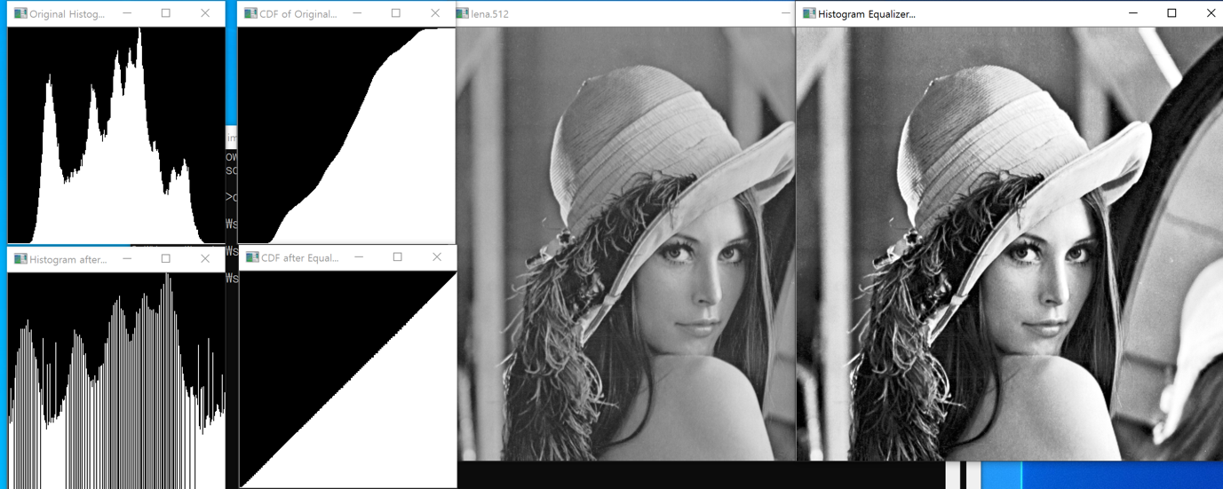

* + 1. 코드실행시cmd에서 imageprocessing.exe face.256 256 256 했을 시

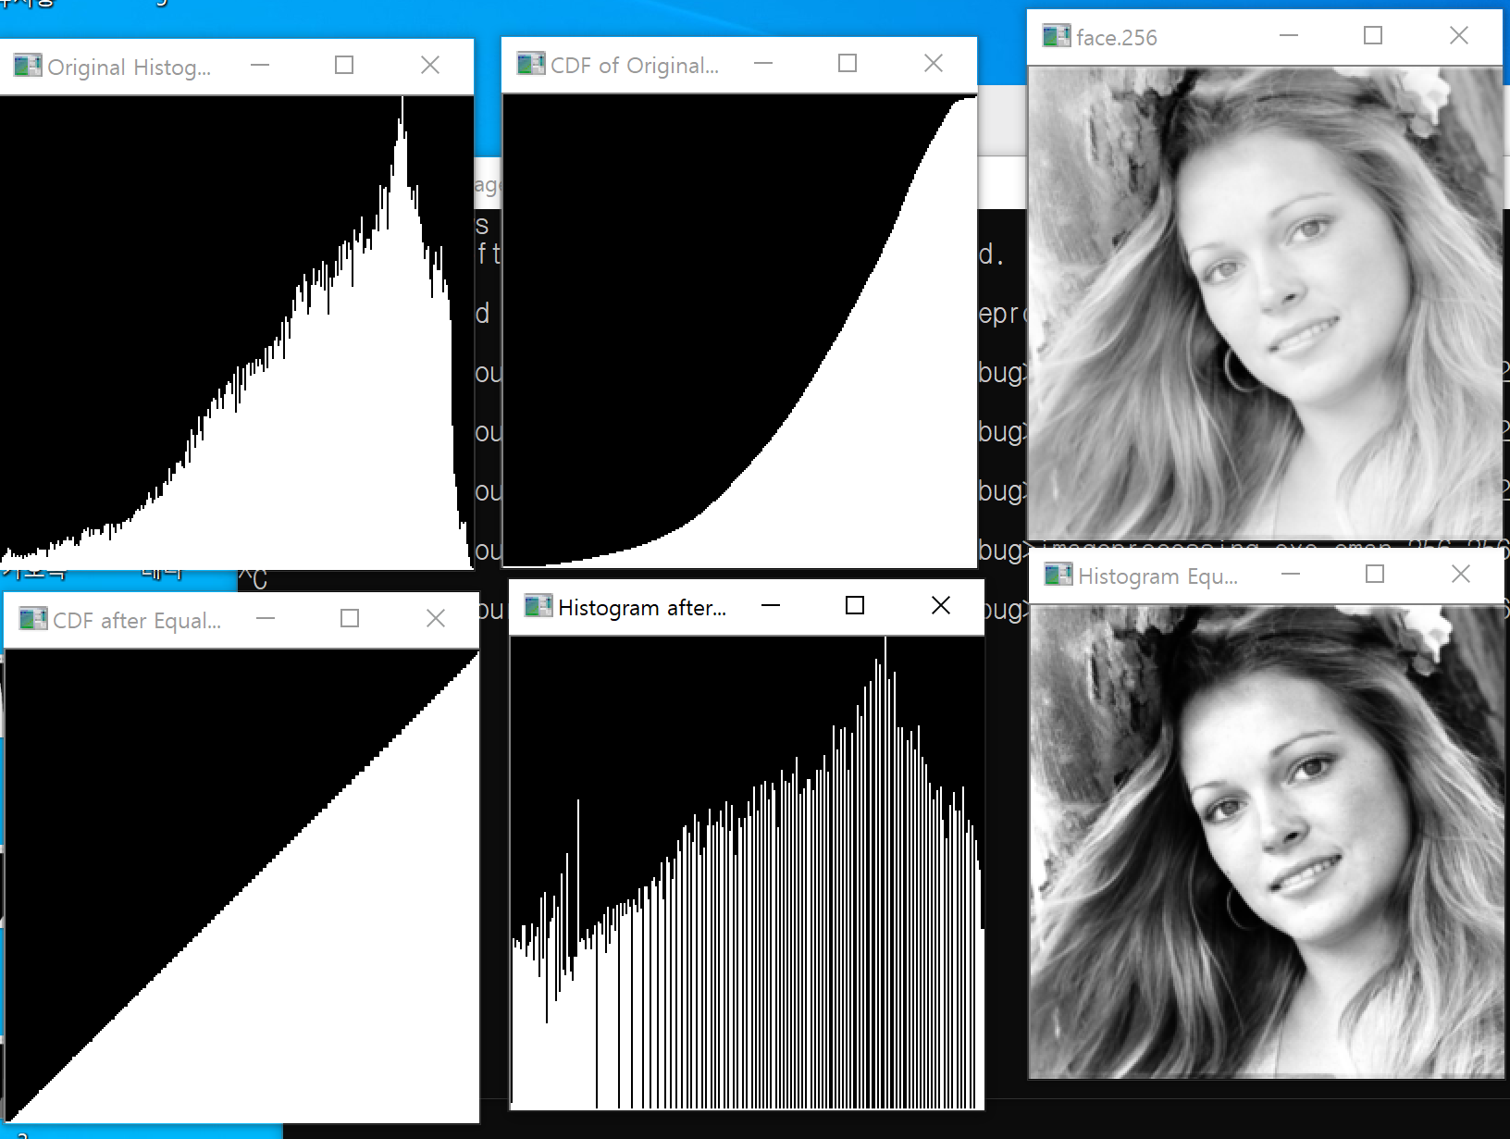

* + 1. 코드실행시cmd에서 imageprocessing.exe cman.256 256 256 했을시

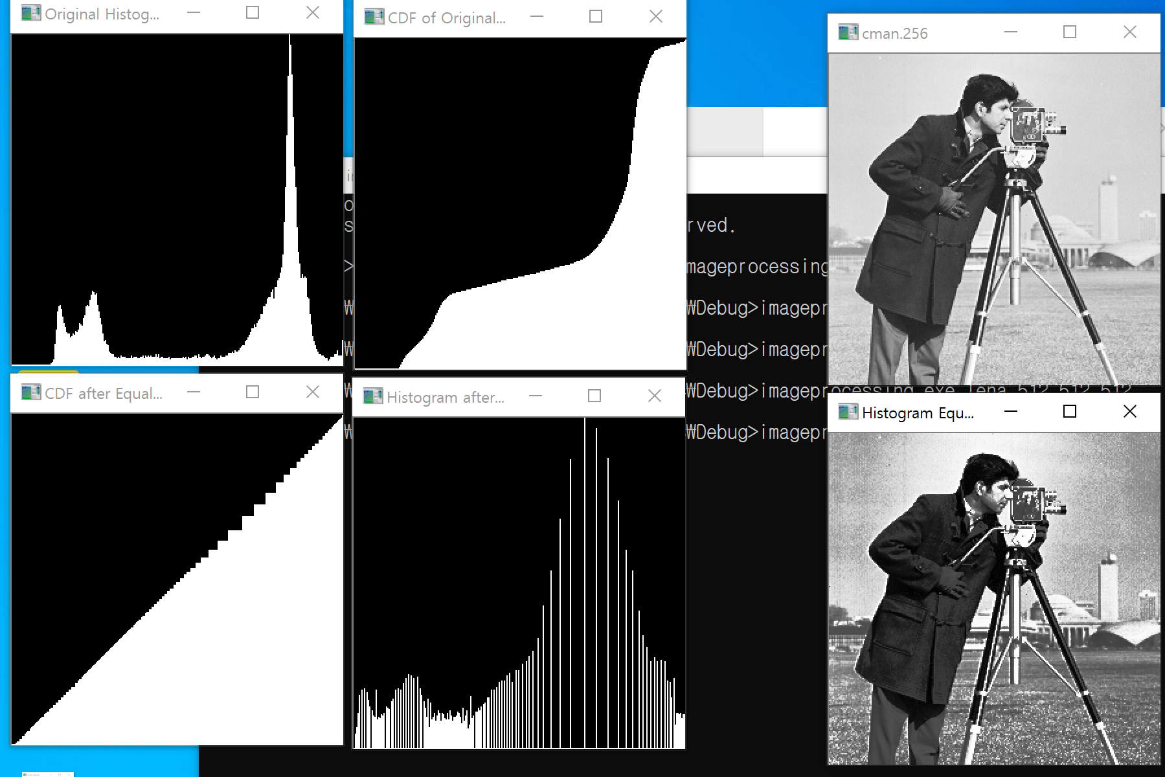

1. Histogram Specification
   1. 소스코드

**//원본을 비교할이미지 감마에 맞춤.**

**void** get_Match(uchar** img, uchar** result_img, **int** x_size, **int** y_size, **int** histogram[256], **int** histogramSpec[256], **int** histogramMatch[256])  
{  
 **int** i, j, tmp, matchz = 0;  
 **float** diff;  
 printf("Start HistoGram Specification \n");  
 **for** (i = 0; i < 256; i++)  
 {  
 //초기화  
 histogramMatch[i] = 0;  
 //비교누적분포함수  
 **for** (j = 0; j < 256; j++)  
 {  
 **if** ((i - histogramSpec[j]) > 0)  
 {  
 histogramMatch[i] = j;  
 }  
 }  
 }  
 **for** (i = 0; i < y_size; ++i)  
 **for** (j = 0; j < x_size; ++j)  
 result_img[i][j] = histogramMatch[img[i][j]];  
}

* 1. 실행화면

cmd에서 imegeprocessing.exe face.256 256 256 cman.256 256 256 했을시

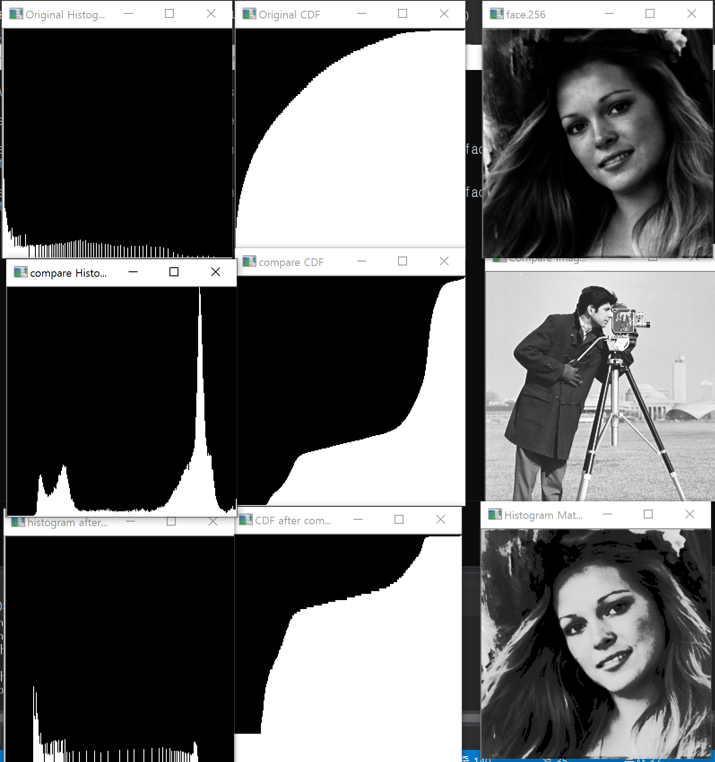

*비교할 이미지가 비교적 밝기 때문에 원본의 CDF가 밝아진다.*